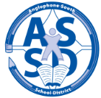
ANGLOPHONE SOUTH SCHOOL DISTRICT
www.asd-s.nbed.nb.ca
OPENING OF SCHOOLS FOR 2017-2018

Welcome back to all students and families from Grand Manan to Sussex Corner for the new school year!
All Kindergarten children will enter school through a staggered entry process on September 5 and 6, 2017 with half of the students attending each day. All Kindergarten children will attend together on September 7. Schools will communicate to families their scheduled time of entry. If you have not provided your child’s immunization record, please do so as soon as possible.
All grades 1-5 students will begin classes on September 5.
For all middle and high school students, there will be a ‘transition day’ with only grades 6 and 9 attending on September 5. Some exceptions to this are: Grades K-8 schools will not have a grade 6 transition day so all students will attend on September 5. Grades 6-12 schools will not have a grade 9 transition day, and in grades K-12 schools there will not be a grade 6 or 9 transition day. The transition day is intended for students who will be starting middle or high school in a different building. If you are unsure, please call your school the week before school begins or check the school website.
Teachers and school administrators will be involved in meetings and professional learning activities the week of August 28, 2017. The complete 2017-18 school calendar can be found on our website www.asd-s.nbed.nb.ca.
TRANSPORTATION INFORMATION
Students should be at their bus stop at least five minutes before the scheduled time. It is normal for bus schedules and stops to be adjusted during the first few days of operation. Your patience in this regard is appreciated.

The district provided busing information to Kindergarten students in a letter over the summer. If you did not get your information, please refer to the district website for busing, call your school or call Transportation at 658-5603.

Busing information can be obtained on the Anglophone South website: www.asd-s.nbed.nb.ca located under “Busing”. If busing is not available via the website, please contact your school of residence after August 30 and someone will be able to assist you.

This year Anglophone South is happy to provide a new service for parents to subscribe to their children’s busing information. The service also provides the ability to subscribe to notifications specific to children, schools and bus runs. The direct link to this service is https://bp.nbed.nb.ca/asds
Saint John Education Centre (High Schools): Students that are eligible to travel on Saint John Transit will have their Student Bus Passes available on the first day of class. Students must sign for and assume responsibility for it and the passes are non-transferable. Passes are not available at the Centre offices.

Best wishes to all students and staff for a happy and safe new year!
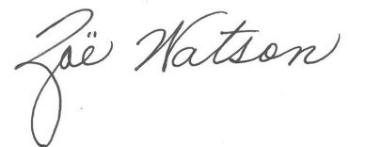
Superintendent

