Website: https://secure1.nbed.nb.ca/sites/district8/schools/westfield/Pages/default.aspx
Twitter: westfield_elem

Communication: At Westfield school we send weekly voicemail, weekly emails, almost daily TWITTER posts, and update the webpage regularly. Twitter messages and voicemail messages are found on our website too, as well as a calendar. Home and School has also sold Fridge Calendars to help remind families of events. I will also send brief Newsletters which tell of family events that are coming up and require RSVPs so that we can make sure we have enough materials and/or food.
_______________________________________________________________________________________
Indigo East Point and Coles MacAllister have adopted our school. We had a great night on Friday at Indigo. People can still help out by purchasing a book off the registry. Indigo will match the book!
https://www.loveofreading.org/school/1369/
October 1

October Family Events
Hallowe’en Literacy Night – October 29 at 6:30
Wear your costume. Come and hear some Hallowe’en stories.

Return by October 11 so that we can start to plan.
RSVP for the Hallowe’en Literacy Night  We plan on coming to the Literacy Night on October 29.  Student name(s):____________________  Class (es): ________________________  # of people attending including the student(s) above: _________  *only one needs to come back per family | RSVP for the Home and School Dance  We plan on coming to the Dance on October 25.  Student name(s):____________________  Class (es): ________________________  # of people attending including the student(s) above: _________  *only one needs to come back per family

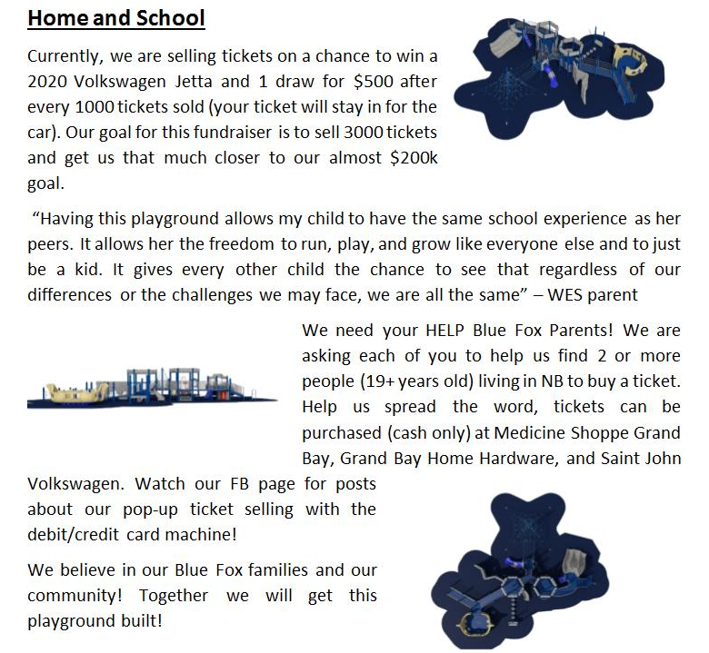
********************************************************************************Hallowe’en Costume auction- Online October 6 to October 10 watch out for this on our FB page Westfield Home and School.
********************************************************************************
Hallowe’en Dance will be held Friday, October 25 from 6pm to 8pm. Cost is $5 per person or $20 a family and there will be a canteen as well. Children must be accompanied by an adult 18 years or older. Get your dancing shoes ready!
*******************************************************************************
Westfield School Fall Photo Fundraiser – Book your spots now!
Saturday, October 5 from 10-2 at Unity Park
1 photo is $10 and 3 photos are $25. (add a Christmas Photo for $10)
Rain location to be secured.
Please see the Westfield Home and School Facebook site for more details.
Email: westfieldplayground@gmail.com

