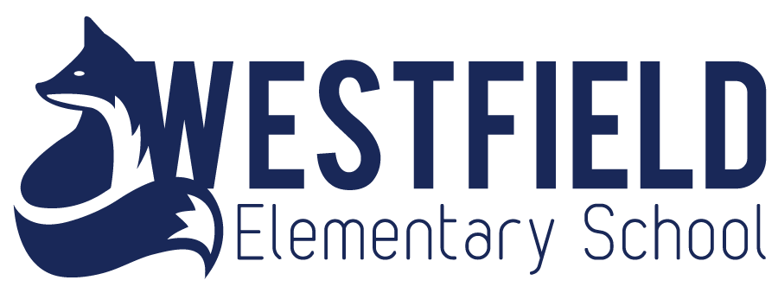
Please remember that we have weekly voicemail, weekly email, almost daily TWITTER posts, and we update the webpage regularly. Twitter messages and voicemail messages are found on our website too as well as a calendar. Newsletters will be mainly for events. _______________________________________________________________________________________
Website: https://secure1.nbed.nb.ca/sites/district8/schools/westfield/Pages/default.aspx
Twitter: westfield_elem
March Dates to note
March Break- March 2-6
March 7 TD Station – Westfield + Inglewood and GBP Community Skate 1:15
March 10- Home and School Meeting
March 17 – Wear Green – Happy St. Patrick’s Day!
March 20 – Rock Your Socks – World Down Syndrome Day
March 22- 27 French Pride Week (March 25 – Acadian Colours day)
March 24 - PSSC meeting

*Remember if there is a snow day, you can always do a good deed for someone you know and read a book!

Attendance Matters
School does start officially at 8:45 (but know that learning starts as soon as students enter the classroom from outside at 8:30). Please get your child to school on time. This concern is totally for your child’s benefit as it often is stressful to enter a classroom after the day’s learning has started. It also distracts the other students when tardy friends enter the room after 8:45.
Students must check in with Kim at the office to receive a tardy slip which they take to their teacher. This means that Kim has gone into the Powerschool System to correct attendance. This takes time. We have way too many late students. Mrs. Johnson will be making calls to see if there is some way to help families that are habitually late or who are missing many days of learning. We care about your children and if there is any way to help, we will.
Thank you.
Heritage Fair
Please join us Wednesday April 1st at 6:30pm for our annual Heritage Fair. Some students in grades 3-5 have been working hard on projects based on the topic of "Bringing the Past Into the Future" and would love to present them to students and parents.

Have a great March Break Everyone!

Home and School
Fundraising of March- This Month students will be getting pledge sheets on the first day back from March Break. The pledges will be to do physical activity of their choosing at school during the lunch hour. We will be having a sock hop for them as well as they can go outside to play. Pledges will raise money for our inclusive accessible playground. Students (and parents) can ask friends, family and call some neighbours. There will be prizes for students to win depending on the amounts raised. Cash or cheques (made out to Westfield Home and School) must be collected and brought into the school the end of March.
Atlantic Home Show- Home and School will have a table set up at the Home Show to sell tickets and take donations for the playground! We will need some parents help over the weekend March 13, 14, 15. We will also looking for students in Grades 4-5 to help ask for donations (parents must be with them). Please contact westfieldplayground@gmail.com or contact Cindy MacCready at 486-1818. Make sure to stop by and visit our table and get your ticket on the Car too!
Fundraising for April- We are hoping to have a vendor sale at the end of April. Tables would be $25 as well as an item donated to our auction. First chance to get a table will be given to parents before we reach out to the public. For more information, please email westfieldplayground@gmail.com

Westfield School is trying hard to find ways to make a difference when it comes to the Environment.
HELP!
OVER THE NEXT FEW MONTHS, WE ARE HOPING TO HAVE STUDENTS BECOME KNOWLEDGABLE ABOUT EARTH, RECYCLING, REUSING, REPURPOSING ETC. EARTH DAY IS APRIL 22 AND WE ARE LOOKING FOR THE FOLLOWING ITEMS FOR PROJECTS.
OLD MAGAZINES | OLD CORKS | OLD MASCARA WANDS (WASH WITH DISH SOAP) | FABRIC RIBBON
OLD CARDS | OLD BOTTLECAPS | SINGLE SOCKS IN GOOD SHAPE | BUTTONS
PLASTIC BAGS | POPCAN TABS | OLD NECKTIES | YARN
PLASTIC BOTTLE CAPS | OLD T-SHIRTS | OLD KEYS | TWINE
OLD CDs | OLD JEANS | OLD RECORDS | THREAD
OLD MARKERS | OLD TOWELS | OLD CRAYON PIECES | NEWSPAPER
FABRIC: FLEECE, COTTON, XMAS PRINTS,

A NEW WES ENVIRONMENTAL PROJECT - THE ECOBRICK !
What is an eco-brick? It is a 2L pop bottle stuffed with clean and dry non-organic and nonrecyclable items like plastic bags, cling wrap, chip packets etc. Use a dowel or wooden spoon to compact everything as tight as you can into the bottle. We would like to use these bricks to make a planter outside of our school!
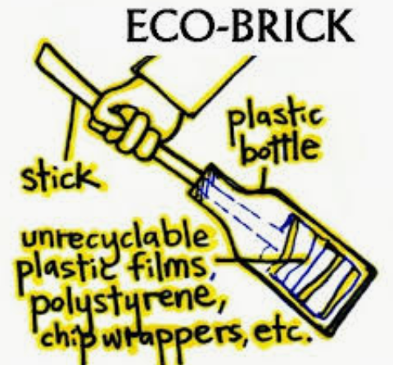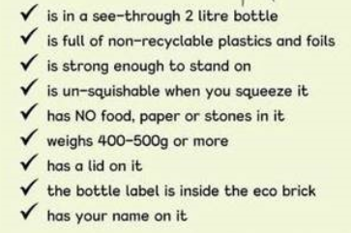

OUR RECYCLING DEPOT COLLECTS:
