Website: https://secure1.nbed.nb.ca/sites/district8/schools/westfield/Pages/default.aspx
Twitter: westfield_elem

Please remember that we have weekly voicemail, weekly emails, almost daily TWITTER posts, and we update the webpage regularly. Twitter messages and voicemail messages are found on our website too as well as a calendar. Newsletters will be mainly for events. _______________________________________________________________________________________
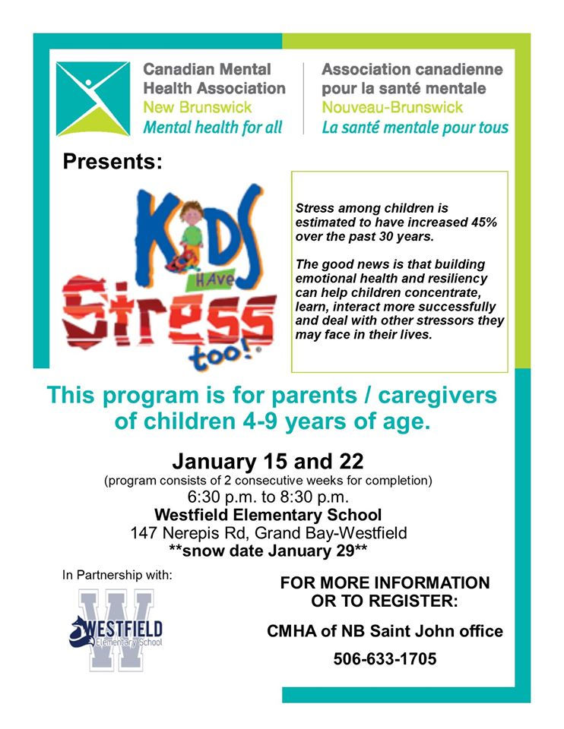
Westfield School Presents…
Kids have Stress Too
Based on discussions with parents and our own observations, we know there are students in our school who struggle with anxiety. If this is your child, please consider coming to this parent workshop. What can we all do to help?
Call the number on the left if you would like to attend.
SCHOOL CLOTHING
Lester’s has agreed to put in another order for school clothing including grade 5 hoodies. There will be a short window to order. Deadline is Friday at midnight. This will be the last opportunity to do so for this academic year. Please call Kim at 757-2020 to tell her what you will be ordering. This call must be followed up with an online order at School Cash Online before the deadline.
Unclaimed 2019 Lost and Found Items will be boxed up on January 10th and donated to charity.

MARK JANUARY 18 ON YOUR CALENDARS! BREAKFAST AT THE RIVER ROAD HUB
GRADE 5 SNIDER MOUNTAIN FUNDRAISER
There will be a breakfast on Saturday, January 18th at the River Road Hub from 8-11 a.m. Funds raised will help support WES Grade 5 Students and their end of year Snider Mountain trip. Adults are $8 and Children are $4. All are welcome and we hope to see you for some yummy food!
Thank you to the River Road Hub for their support.

Home & School News
· There is NO Hot Lunch the first week back of school
· Hot lunch orders are now open for February and closes January 23
· We are in the process of planning a sign making night and having another photography session in February. Make sure to follow us on Facebook for more information.

Give the Gift of Play In 2020
Our Home and School will be focusing on the playground initiative as this will be the last year for fundraising. We could really use your help in getting the word out about how to give to the playground.
1. Buy a car ticket from one of our locations (WES, Medicine Shoppe GB, Home Hardware GB and SJ Volkswagen)
2. We are accepting donations by e-transfer, they can email westfieldplayground@gmail.com for more information.
3. Support one of our fundraisers coming up this year. This playground will benefit so many students and children in the community. Thank you for your support! Together we can get this playground built!

January Dates to Note:
River Valley Community Center is trying to win the Kraft Hockeyville Grand Prize! Please consider helping them out in this quest!
- $250,000 towards upgrades to the Grand Prize winning Arena as nominated in the Story Submission
- The opportunity to host an NHL Pre-Season hockey game that will be played in the Grand Prize winning Arena (or an Alternative Arena if necessary) on a date between September 1, 2020 and October 1, 2020
- The “Kraft Hockeyville Canada 2020” title and trophy for one (1) year.
There are also three 2nd place prizes of $25k
Here is the link to nominate RVCC https://www.krafthockeyville.ca/community/11E9F686BBECB8FE81807B23EA662A63?phase=entry#/community/11E9F686BBECB8FE81807B23EA662A63
You will notice that this is a point system contest. The more nominations we get the better the chances are. Each submission earns us points. Each submission needs to be unique and not copied.

January 6: teachers return to school
January 7 : students return to school
Home and School Meeting at 6:30 (New members welcome!)
January 21: PSSC meeting at 6:30
January 27: NO SCHOOL : Professional Learning Day for Teachers
January 28: Welcome to Kindergarten Event for students entering K in the fall. Phone calls will be made
January 7-10 to schedule session times. This does not affect our current students at all.
January 30: World Read Aloud Day event.
February Skating: February 13 and 27th - more details to come closer to the date.

*Remember if there is a snow day, you can always do a good deed for someone you know and read a book!

- Book SWAP. Bring gently used books to trade with others. When you enter, see our donation volunteers who will give you a 1-2 sticker based on how many books you have brought to trade. While you may bring more books to donate, and we would LOVE this, the sticker will indicate how many books you may take home at the end of the night from our donation tables.
- Wear your PJs OR Dress as your Favourite Book Character! Those in book Character Costumes will receive a ballot for a book basket.
- Doors open at 6:00 - dropping off donations, getting your floor spot, photo booth happens while waiting for the event to start at 6:30
- 6:30-6:40 Welcome – Karaoke Singalong component
- 6:40- 6:50 Mrs. Johnson will read aloud one of her favourite books
- 6:50-7:05 Read Aloud with families
(Flashlight Reading – bring your flashlight and cuddle up close! Lights will be dimmed)
- 7:05-7:25 Bingo for Books
- 7:30 Prize drawn for costume component.
Choosing of your books based on swap number if you have not had an opportunity already.
Family Literacy Event on January 30 - 6:30
Remember to take
- Costume or PJs
- Blanket
- Stuffed animal
- Books to donate
- Books to read
- flashlight
*Feel free to bring book donations to school on the day Students can bring in books to the office before January 30 can get their tickets early
Indicating the number of swap books they can get that evening.

Literacy Night RSVP – due Jan.20
Student Name:____________________
Teacher: ________________________

Total number of family members attending: _______

