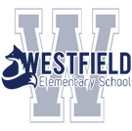 **BLUE FOX BULLETIN – DECEMBER 2019**

LOOKING FOR DONATIONS Looking for gently used items that can go in the student Christmas Yard Sale. Wallets, scarves, ties, mugs, belts, knick-knacks, etc. These items will be purchased by students for a small fee. We will also accept plastic bags. Thank you for supporting this event. Things need to fit in book bags and we can not accept clothes or stuffed animals. We would like to have items by December 6 to see if we have enough items to proceed with the sale.

**Important December Dates**

December 10 Ornament Making evening see below

11/12 – If the Bazaar is to proceed it will begin on this day. Items are 50 cents

18 – Concert – see back of this page.

20 S.T.E.A.M .day

20 FULL DAY of school !!!!

**JANUARY:**  Students return on January 7!

**Kids Have Stress Too!** Westfield School will host a two night parent workshop put on by the Canadian Mental Health Association. Parents will walk away with a toolkit of strategies to help their child cope with anxiety and stress. It is free. Please let the office know if you plan on attending. You must commit to the two evenings. January 15 and 22 from 6:30-8:30.

Please check out our website for a full calendar of events.

<https://secure1.nbed.nb.ca/sites/district8/schools/westfield/Pages/default.aspx>

Also follow Westfield school on Twitter: @westfield_elem

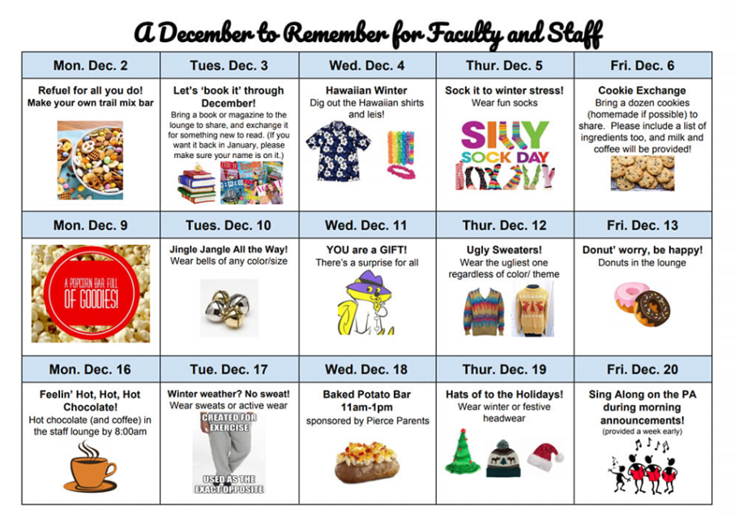

**Candy Cane**

**RED/WHITE**

**Day**

**PJ day!**

**Full day.**

**Tinsel Tuesday!**

Bling, sparkle and shine!

**Westfield Pride**

Wear WES clothes, Wear your fox items!

***Concert day***

**Hats off to the Holidays!**

Headwear…hats, headbands…etc.

**ELF yourself!**

Green and Red

**Green**

**or Grinch Day!**

**Snowman attire**

or

Wear White

**Flannel Friday!**

Wear your plaid today!

**DECEMBER SPIRIT DAYS – not mandatory.**

**Home and School reminders:**

Dec. 3 H/S meetings (new members welcome)

December 8 (9 pm) voting ends for online auction

Dec. 10 Ornament Making Night from 6-7 – no cost – in the Commons. Donations will be accepted for the Inclusionary Playground Piece.

December 17 Winter Pancake Lunch with a snow date of Tuesday Jan.7 (free)

No healthy lunch between Dec. 16-20 and Jan. 6-10. Please send lunch.

Lunch ordering is open until Dec. 23.

**Snow Days Happen**: Try these snow day challenges if they do:

1. Do some baking and practice your measurement! (Give some of it away to community helpers.)
2. Write some kind notes to special people in your life.
3. Read a book.
4. Go outside and do some shoveling for your family or a neighbor.

**WIN the Best Seats in the House and VIP parking!**

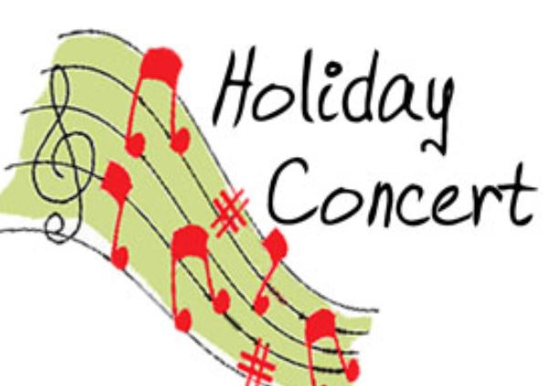**December 18**

**Two Showings- 9:00 and 12:00**

(We encourage family of students A-L to attend the morning show and M-Z attend the afternoon show, if at all possible) We also ask that you refrain from leaving during the concert and remain until the end (or exit with consideration if required).

We will be collecting Breakfast items for the WES Breakfast program. Suggestions:

* Reduced Sugar / Whole Grain Cereals without nuts
* Made Good Apple Cinnamon Granola Bars (Costco), Strawberry Granola Bars
* Made Good Vanilla Crispy Squares
* PC Blue Menu Multigrain English Muffins (cheapest at No Frills, a subsidiary of Loblaws)
* Quaker Chewy Apple Fruit Crumble Granola Bars
* Quaker Rice Cakes: Lightly Salted Butter Popcorn Flavor and White Cheddar Flavor
* Rice Krispies Brown Rice Squares
* Items to be frozen: yogurt tubes, cheese strings etc.

Dear Parents & Guardians,



Westfield School is selling tickets for the chance to win two front row seats reserved as “The Best Seats” at the Christmas Concert on Wednesday, December 18 and also one reserved parking spot! There will be a draw for the morning performance and a draw for the afternoon performance.

Tickets for the draw may be purchased by filling out the bottom portion of this memo and sending it back to your child’s homeroom teacher by Friday, December 14th.

Tickets are $2.00 each or 3 for $5.00

Parents’ names will be put on the ballot(s) and placed in the ballot box. Both draws will take place on Monday, December 18th at 3:00pm. We will contact the winners by phone on Monday to let them know they can come to the concert at the last minute and still have excellent parking and seats!

All proceeds will help purchase technology within the school.

Good luck and thank you for supporting this fundraiser.

Return the slip with your money in a plastic bag or envelope.

----­-----------------------------------------------------------------------------------------------------------------------------------

Westfield School : “THE BEST SEATS IN THE HOUSE & VIP PARKING”

Name__________________________________ Phone Number_________________________

Please circle preference below: I would like to be entered in the draw for the

morning performance OR afternoon performance

Number of tickets _________ Amount Enclosed________________