**Hello Blue Fox Family,**

We wanted to take this opportunity to introduce ourselves. We are excited to be part of Westfield School and look forward to meeting all our new students and families in the Fall.

***Louise Johnson, Principal***

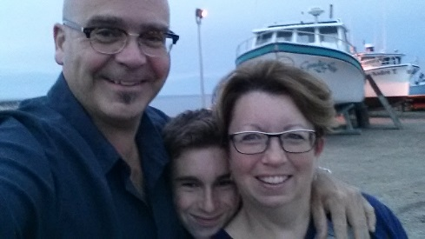My family and I have been living in the area for the last 16 years and I am happy to say that by becoming principal at Westfield, I am cutting my commute down to about two minutes! I am originally from PEI but have taught in Mexico, NWT, NS and all over NB.

My husband, Eric and I have a son, Calder who 14 and attends Harbour View High School.

Some of my favorite things include, having fun with my family and friends, reading, and going for walks. Over the summer, we love relaxing by the pool, camping, fly-fishing and kayaking.

On a professional note, I am finishing up a year as an ASD-S Respect and Diversity Lead. This is a new position created this year through the Premier’s 10 Year Education Plan and involves teaching fellow educators and observing/advising in their classrooms on topics of resiliency, restorative practices, positive behaviour supports, social-emotional learning and behaviour planning – just to name a few. I also can proudly say that I received an award in 2015 as one of Canada’s Outstanding Principals for my many years as Principal at Loch Lomond School. I am presently completing a Youth Mental Health Certificate from Mount Royal University in Calgary.

***Amy McClure, Vice-Principal***

I am a proud Nova Scotian from a small town in the heart of the province, but Saint John is now my home. I’ve been a teacher for over ten years and was most recently Vice-Principal at Havelock School. I have enjoyed teaching a variety of grade levels / subject areas and have spent most of my career working in community schools in our city’s priority neighbourhoods. Prior to becoming an administrator I also spent time working as a Positive Behaviour Intervention Facilitator and Behaviour Intervention Teacher for the District Office.

Away from work, I spend as much time as possible outside.  My husband and I live outside the city with our two feisty daughters (Jillian-age 2 and Alyvia-Maye-age 6). We use our free time to explore, hike and find adventures in our backyard.  Education is my primary passion, but I also love rugby and have been involved in the sport for nearly 20 years.  While I no longer play, I continue to share my passion for the sport through coaching and refereeing.

I am looking forward to joining the Westfield community and learning alongside my new team!

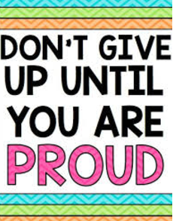 **A few beliefs that we have about students and learning are:**

* We believe that each student should enjoy coming to school every day and strive to make that a reality for each one of them.
* We believe that every child can be successful. Success looks differently for everyone.
* 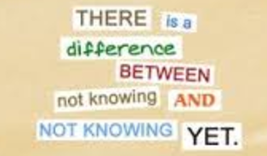We believe that working together and seeking advice from students, parents, and community is invaluable to making informed and fair decisions. We always value input and learning from others.
* We believe that open, honest, and frequent communication is important and encourage parents to contact us anytime when they have a concern or question.

Also, we will have our **Meet the Staff/Open House** on August 29 starting @ 6:00. We will also be looking for representatives for the Parent School Support Committee on that night. Your input is valuable to us; make sure you have your say!

If you ever have any compliments, questions or concerns about what is happening at our school, please let us know. We like to make sure that we follow up with parents promptly. We look forward to having a wonderful year with all the Blue Fox students and families.

Sincerely,

Your partners in your child’s education,

*Mrs. Louise Johnson -* Principal of Westfield School

*Mrs. Amy McClure -* VP of Westfield School

***HELP!*** *A makerspace is a place where students can gather to create, invent, tinker, explore and discover using a variety of tools and materials.*

*To start on our journey towards incorporating Makerspace components into the Westfield library-technology space, we are looking for any of the following building materials:*

* *Plastic bottle caps, yogurt containers, pudding dishes, CDs, Keurig cups, pop tabs, corks, Pringles cans,*
* *Baby food jars, baby wipe containers, Q-tips, cotton balls,*
* *toilet paper and paper towel tubes, cereal boxes, cupcake liners, egg cartons, toothpaste or Kleenex boxes*
* *Styrofoam trays, Styrofoam peanut or chunks, bubble wrap*
* *yarn, string, ribbon, buttons, beads, or other craft materials*
* *zip-ties, washers, screws, nuts and bolts, twist ties*
* *any kind of tape, variety of glue, glue sticks, glue guns,*
* *clothespins, popsicle sticks, toothpicks, skewers, tongue depressors, chopsticks,*
* *plastic cups, paper cups, paper plates, straws, pie plates, magazines, newspapers*
* *tools– scissors, hammers, levels, wrenches, screwdrivers*
* *and of course- Lego, K’nex, Lincoln logs, or any type of construction toy if you see any at yard sales!*

***THANK YOU FOR YOUR HELP!***