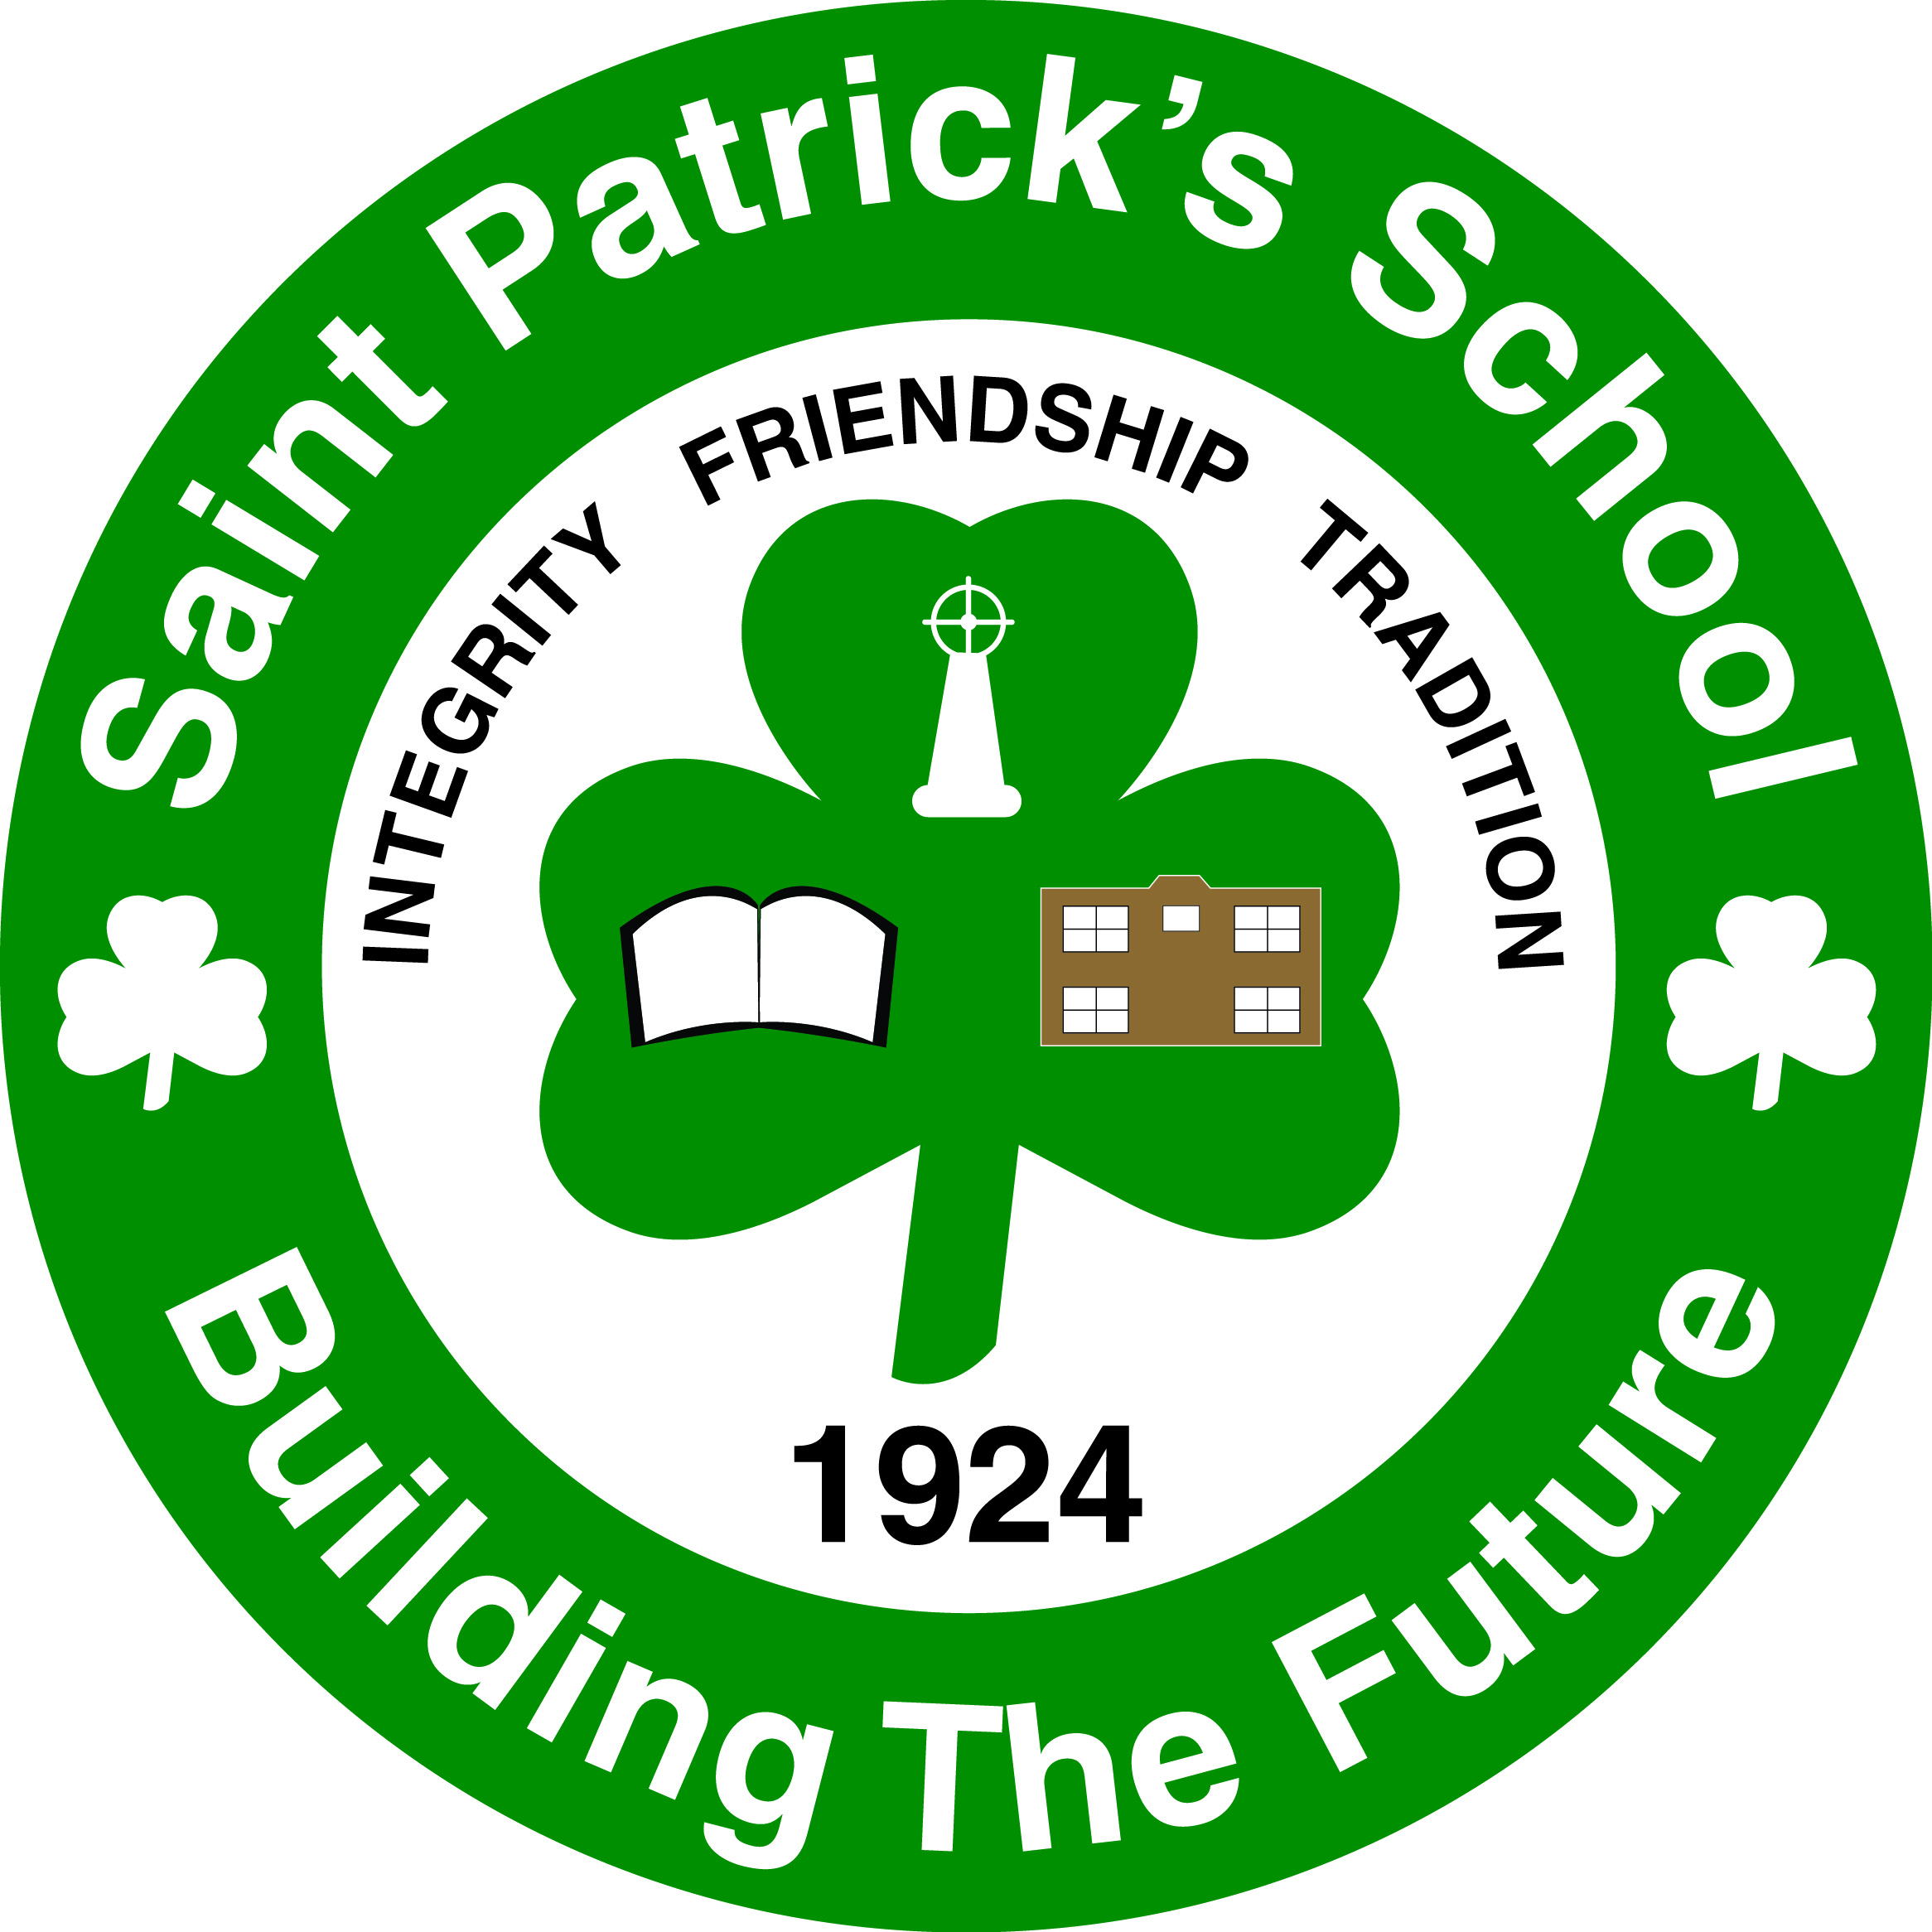

To: Parents/Guardians of St. Pat’s Newcomb Ball Players
From: Michael Wilson, Principal
Date: January 9, 2014
Re: Newcomb Ball Jamboree
We are pleased to say that your child has been chosen to represent St. Patrick’s at the West Side Schools Newcomb Ball Jamboree at Island View School on Tuesday, February 4 from 3:15 to 5:15 p.m. The “Kids on the Go” bus will pick-up St. Pat’s students to and from St. Patrick’s School and Island View School. The bus will leave by 3:00 and they will return by 5:15 to St. Patrick’s School.

Your child’s participation is a privilege, so students behind in their work or due to misbehavior may be removed from the Jamboree.

Please return the bottom portion to your child’s homeroom teacher. This must be returned for your child to attend. You can check more than one item below.

If you have any questions, please call me at 658-5362.

Yours truly,

Mike Wilson
Check all that apply:

Please print your child’s name ___________________________

_____ I give my son/daughter permission to attend the jamboree and to travel by bus.

_____ My child will be walking home from St. Patrick’s school when he/she returns at 5:15 p.m.

_____ My child will be picked-up at Island View School by his/her parent/guardian.

_____ My child will be picked-up at St. Patrick’s School at 5:15 p.m. when the bus arrives.

Parent Signature:______________________________________

Contact number during the day:______________________

