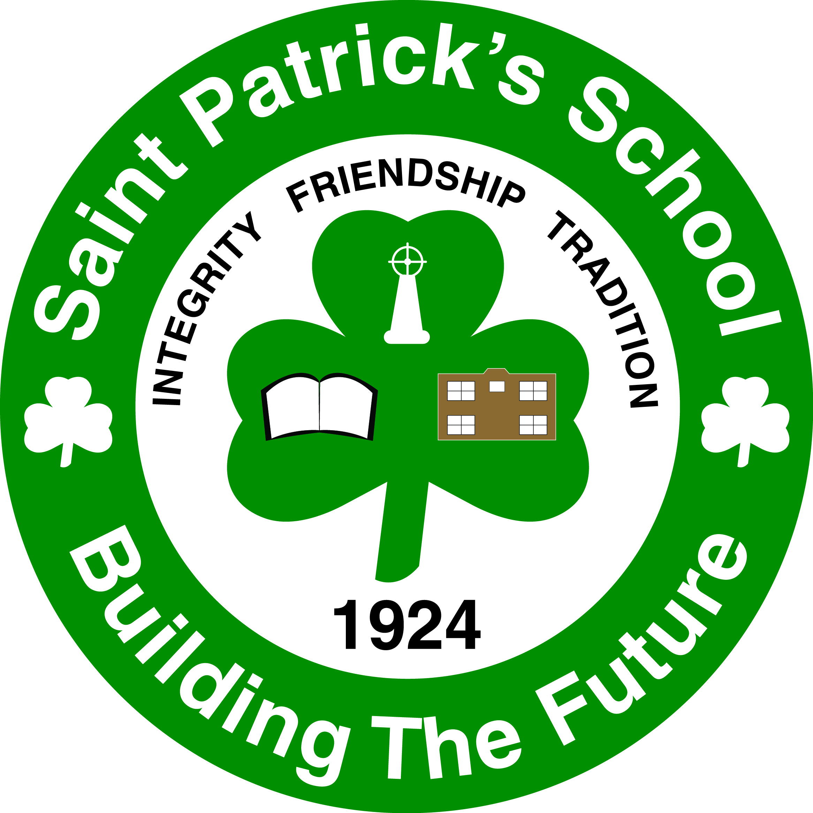
To: Parents/Guardians of Basketball Jamboree Participants
From: Michael Wilson, Principal
Date: November 18, 2013
Re: Basketball
We are pleased to say that your child has been chosen to represent St. Patrick’s at the Basketball Jamboree at Morna Heights School on Tues. Dec. 3rd from 3:00 to 5:15 p.m. “The Kids on the Go” bus or yellow bus will pick-up St. Pat’s students to and from St. Patrick’s School and Morna Heights School. The bus will leave by 2:45 and they will return by 5:15 to St. Patrick’s School.

Please return the bottom portion to your child’s homeroom teacher. This must be returned for your child to attend.

Please remember your child’s participation is a privilege and may not be able to attend if their school work is incomplete or their behavior has not been satisfactory.

If you have any questions, please call me at 658-5362.

Yours truly,

Michael Wilson

Check all that apply (You may check more than one option):

Basketball Jamboree

Please print your child’s name ___________________________

_____ I give my son/daughter permission to attend the jamboree and to travel by bus.

_____ My child will be walking home from St. Patrick’s school when he/she returns at 5:15 p.m.

_____ My child will be picked-up at Morna Heights School by his/her parent/guardian.

_____ My child will be picked-up at St. Patrick’s School at 5:15 p.m. when the bus arrives.

Parent Signature: ______________________________________

Contact number during the day:______________________

