How to sign-in to your Office 365 Account
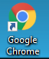
- Open Google Chrome. (Found on the Desktop)

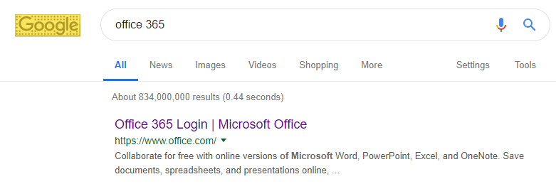
- Search for Office 365 and open the first link

- Click the “Sign in” button.
- Input your “SCHOOL EMAIL”. (Example: UserName@nbss.nbed.nb.ca) – The UserName is what you use to login to the WIFI or a computer. Make sure you use the SAME School Email Format given above.
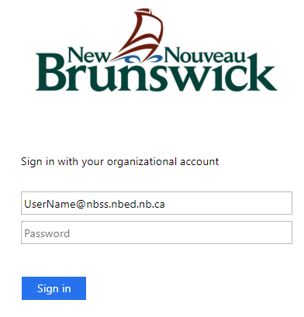
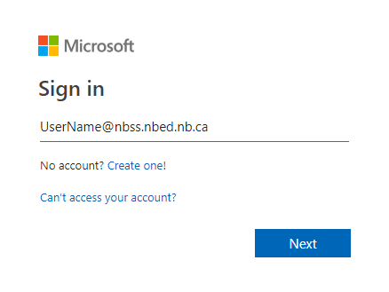

- After you enter your email and click “Next” it should take you to another website where you must re-enter your School Email and Password.

- You will be redirected to your Office 365 Account after you click Sign in.

