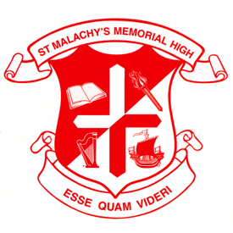
ST. MALACHY’S GRAD CLASS 2019
ACTIVITY SCHEDULE
*****

Monday, June 3, 2019
Grad Class BBQ
St. Malachy’s Cafeteria
5:30 – 8:00 PM
Yearbooks will be distributed to Gr. 12’s who have ordered them.

Friday, June 14, 2019
St. Malachy’s Alumni Dinner
St. Malachy’s Memorial High School
Bishop Bray Gymnasium
Doors Open - 6:00 PM, Dinner - 7:00 PM
Tickets: $20.00 for Class of 2019

Saturday, June 15, 2019
Graduation Prom
Marco Polo Cruise Ship Terminal
Assemble – 7:30 PM, Grand March – 8:00 PM, Dance 8:00 PM – 11:00 PM
First 2-3 songs for the grads and parents.

Tuesday, June 18, 2019
Baccalaureate Service
(Non-denominational Service for Grads, Family and Friends)
Location-Cathedral
Assemble – 6:40 PM, Service – 7:00 PM
Reception to follow

Wednesday, June 19, 2019
Home Reports for Grad Class of 2019
Pickup – 9:00 AM
Graduation tickets are available with your report cards.

Thursday, June 20, 2019
Graduation Rehearsal
St. Malachy’s Auditorium - 12:45 PM
Attendance is mandatory. Graduation gowns distributed after rehearsal.

Thursday, June 20, 2019
Graduation Ceremony
Imperial Theatre – 7:00 PM
Assemble at 6:30 PM
Reception to follow at St. Malachy’s.

Thursday, June 20, 2019
Safe Grad
Students travel together by bus.

