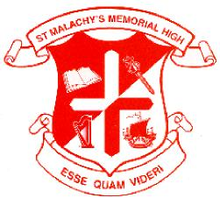ST. MALACHY’S GRAD CLASS 2013
ACTIVITY SCHEDULE
*****
June 3rd, 2013 Monday
Grad Class BBQ
St. Malachy’s Cafeteria
5:30 – 8:00 P. M.
Year Books will be distributed to the Gr. 12s at this time

June 14th, 2013 Friday
St. Malachy’s Alumni Reunion Dinner
St. Malachy’s Memorial High School
Bishop Bray Gymnasium
6:00 p.m. (doors open) 7:00 P. M. (Dinner)
$20.00 Class of 2013

June 17th, 2013 Monday
Baccalaureate Service
(Non-denominational Sevice for Grads and Family/Relatives and Friends)
Cathedral of the Immaculate Conception
(assemble at 6:40 P. M )
*Reception to follow Bishop’s Palace located beside the Cathedral.

June 18th, 2013 Tuesday
Graduation Prom
Delta
(assemble at 6:45 for “Grand March” at 7:30)
Dance 8:00 P. M. - 11:00 P. M.
*First 2-3 songs for the grads and parents.

June 19th, 2013 Wednesday
Home Reports for Grad Class of 2013
2:30 P. M.
Tickets available with your report cards June 19th, 2:30 P. M.

June 21^{st,} 2013 Friday
Graduation Rehearsal
STM Auditorium 12:45 P. M.
(attendance is mandatory, receive gowns afterwards)

June 21st, 2013 Friday
Graduation Ceremony
Imperial Theater
7:30 p.m. Reception to follow Bishop Bray Gymnasium

June 21st, 2013 Monday
Safe Grad
Students leave together after the Ceremony by bus, from the school at approximately 11:30 P. M. and will return to the school at 6:00 A. M.
(Details TBA)

