Downloading Office 365 Apps

- Sign-in to your Office 365 Account. 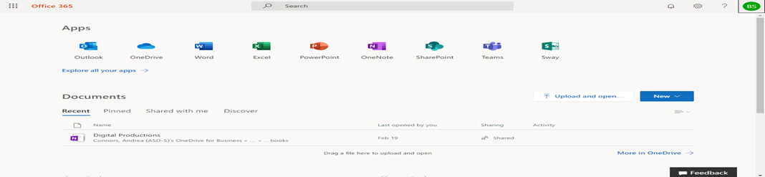

- Click the Account Photo Icon in the (Top-Right-Corner). 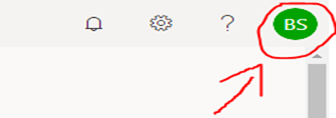

- Click on your Account Photo Icon. Then Click on My Account. 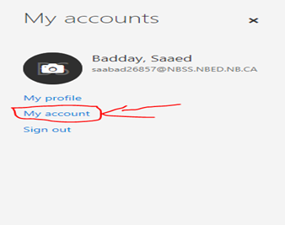
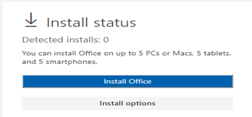
- Click Install Office and the download should start.

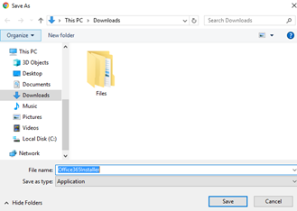
- Choose a place to save the file.

