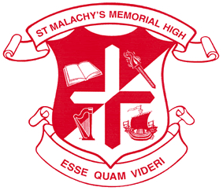
Focus On Information Technology (FIT) St. Malachy’s Memorial High School

Rationale
St. Malachy’s Memorial High School is committed to educating the whole person. Through a rigorous and comprehensive program of studies we prepare students – academically, socially and morally – to assume their places as conscientious, involved and contributing members of society.
The above mission statement acts as our guide in the development of our students. The FIT Program, fits directly with our rationale of offering current courses and possible career paths for our students
Approach
The approach was one of simplicity. As a team, we identified a room to designate solely to the Tech Support side of the program then establish a core group of teachers and a coordinator. The team consists of the following:
Mike Whelton, Vice Principal
Ray O’Donnell, SPR For Technology, FIT Coordinator
Ryan Murphy – Teacher, Tech Support/Digital Technoloyg/IT 120/Computer Science
Charlene Melanson – Teacher, Business Organization & Management/Entrepreneurship
Guidance Department
Having the same core group of professionals makes tracking/monitoring student’s progress within the FIT Program more efficient

Tracking
In order for students to flow through the program successfully, we establish a tracking form which is used at the end of first semester then again at the end of second semester. Through coordination with our guidance department, we track students using a spreadsheet based on the information of the tracking sheet, paying close attention to graduates then looking at course placement for those graduating the next year.
Sheet Sample
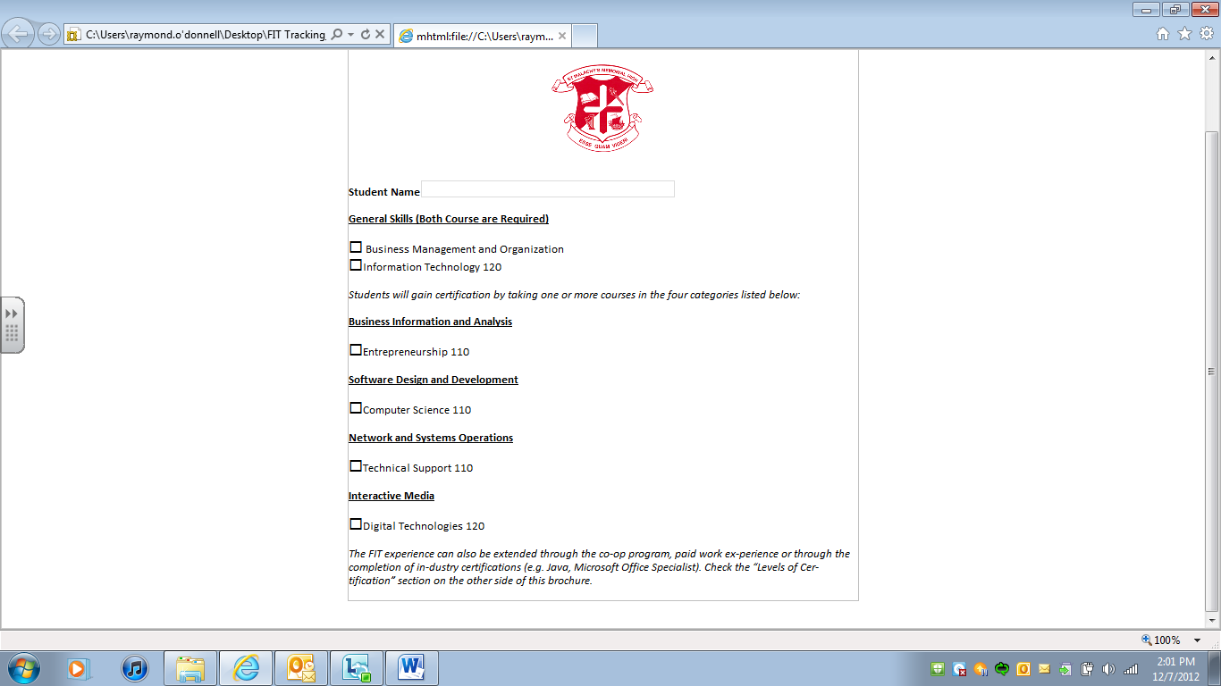

We also, through the help of Guidance and our administration, indicate the FIT Tracking in all subject areas within our course registration booklet. Course have the “FIT” wording beside them to help students choose the area of study.

Tech Support Facility

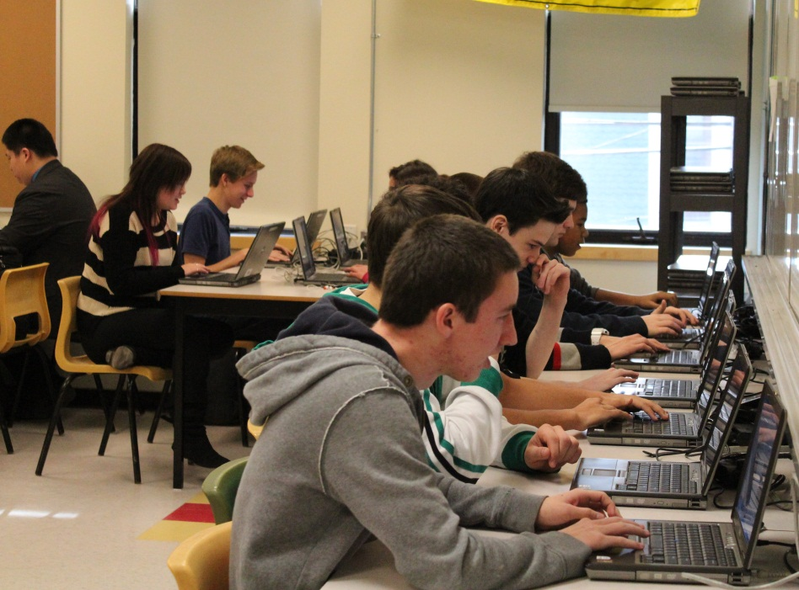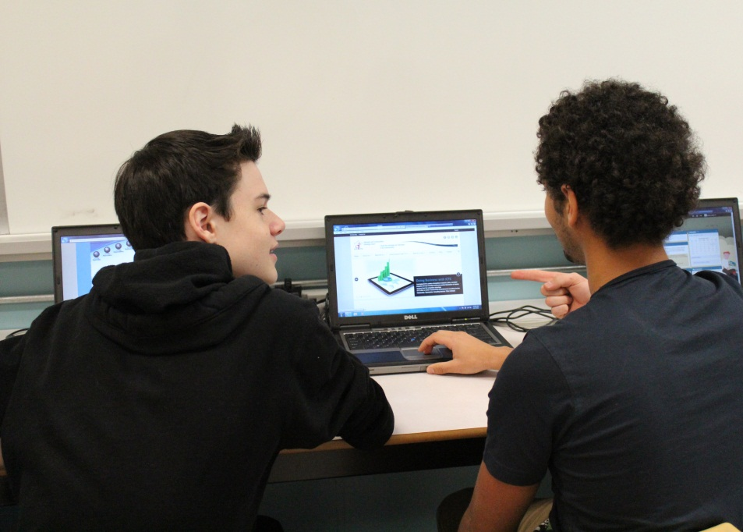

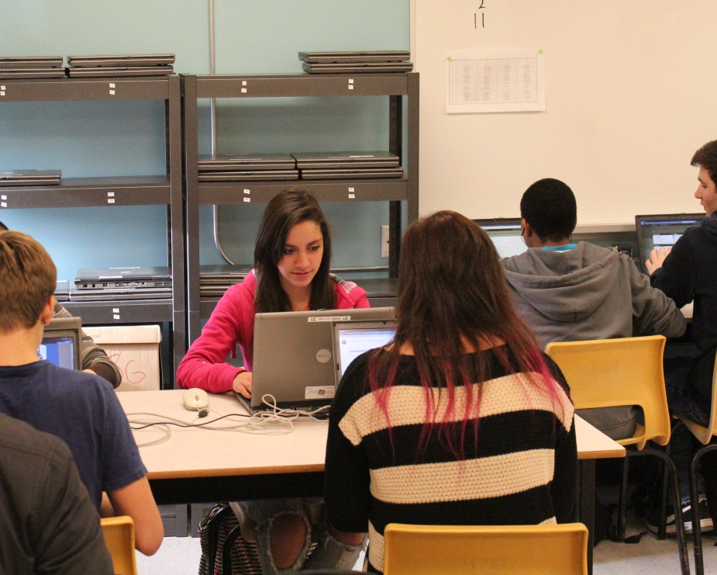
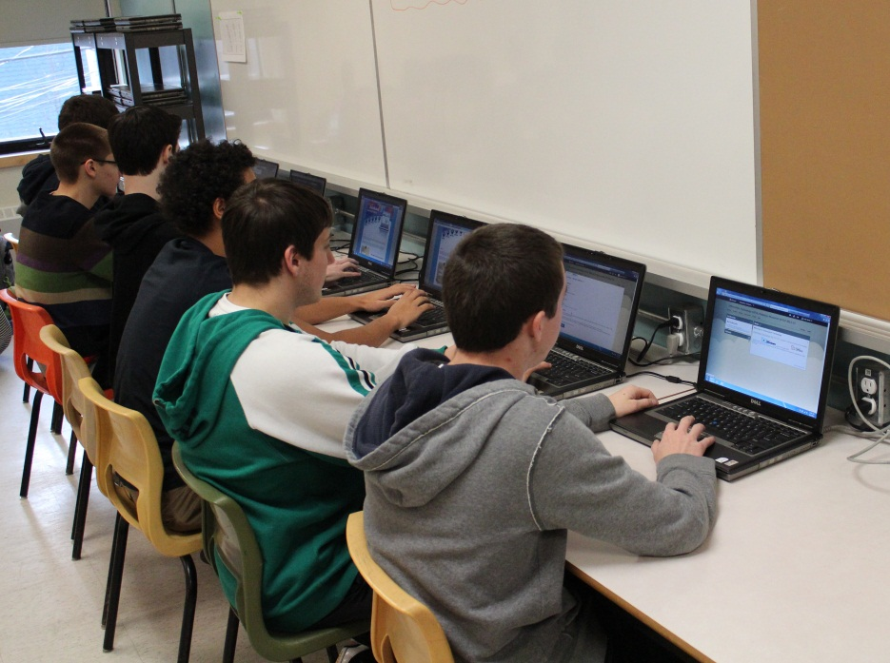

Pearson View Testing Area

We are fortunate to have the opportunity to house a IT Testing facility within our school through the cooperation of Pearson View. There are two areas shown below, the first being the administration area and the second is the testing area. These areas are separate and secure and must adhere to Pearson View Testing Protocals. The school technician, as well as the SPR For Technology were required to under go testing in order to be qualified to administer testing. As of present, we only offer private testing to our students.

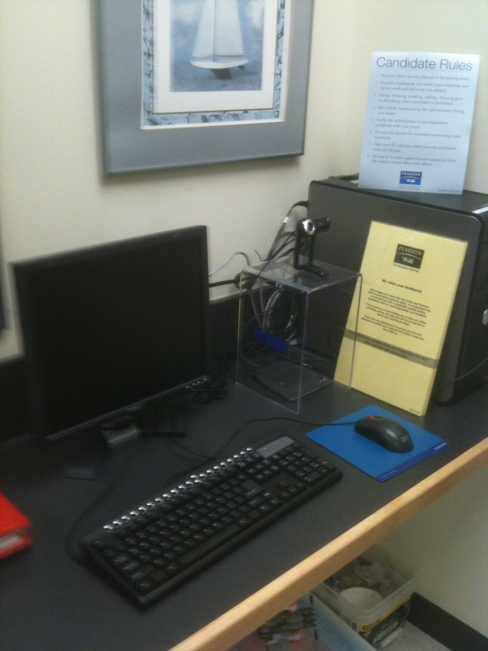
The administration area is located in a separate office.

The student testing area consists of 4 computers separated throughout the back area of the adjoining computer lab. These machines were set up by our technician and enables us to test 4 students at a time
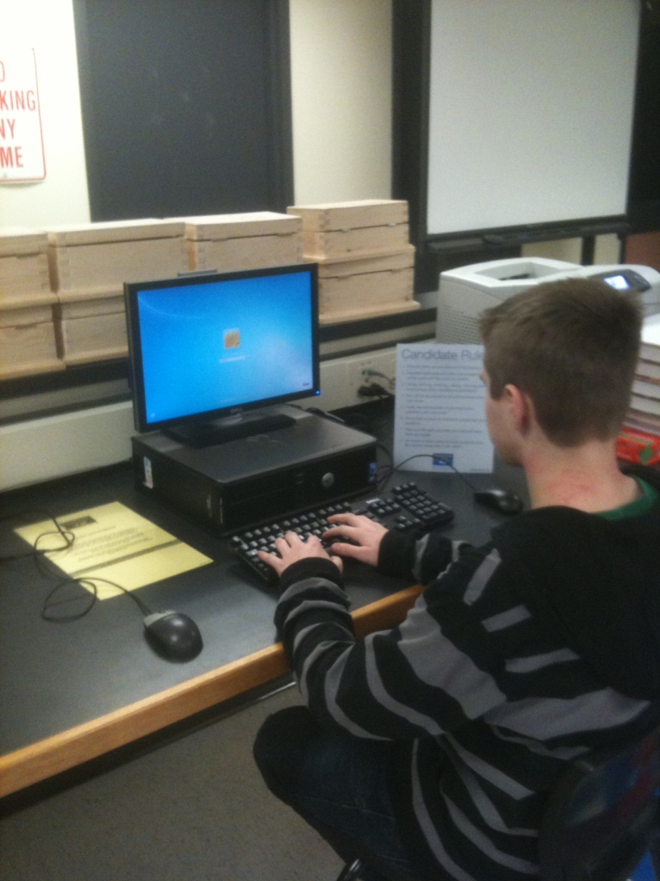
Again, strick protocals are in place for secure testing. Students are required to sign off on a Canidate Rules Agreement and must be logged in on the center log in sheet. These sheets are kept in a Pearson View Canidate Log In Binder.

Problems/Concerns
The major concerns were firstly set up. Our technician put in long hours to sort out the logistics of secure set up then to enable access through Frederiction. As well, the administration test was long and required about 12 hours of prep prior to writing. Our other concern was the test the students were doing covered 16 chapters of the of CISCO material for IT Fundalmentals. The curriculum for the IT Course only covered the first 10 chapters. As a result of this, we submitted a local option course which we will run second semester to cover the final 6 Chapters and combine practice testing in order to better prepare our students for final industry standard testing.

