Week Two Notes

SCROLL SAWS
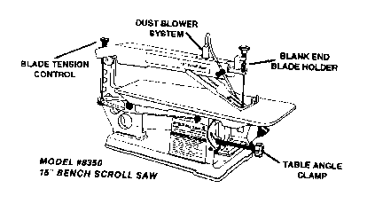
BLADES
Most units sold today utilize a 5" blade length. Two different types that are produced for a scroll saw are pinned, or blank end blades. Pinned blades have a small pin on each end, while blank end blades have none, therefore, requiring blade holders.
Blank end blades allow for smaller radiuses to be cut, because with the omission of the pin, the blade can be made much smaller.
Pinned blades are quicker for blade change, because no holders are required. Only the tension knob on the machine need be adjusted. Pin end blades work equally as well as the blank end blades and are easiest to use by the novice. Whether you use pinned or blank end bIades, proper tension is very important. In both cases, the tension on these blades must be very tight. With the machine disconnected from its power source, you can test this tension. Using your fingernail on the blade like a guitar string, the blade should ping like a "high C".
SPECIAL FEATURES
A) There are two important features of a scroll that make it different than the functions of a band saw.
1. The scroll saw allows for cutting within a workpiece (inside diameters) by drilling a hole large enough for the scroll saw blade to fit into. This can be done with either pinned or blank end blades. This allows the machine to work as a drill press by cutting various size holes.
The continuous band of the Band Saw blade makes this cut impossible.
2. Because of the smaller blade thickness and width, the scroll saw can cut tighter radiuses than a band saw, almost being able to turn at a 90 degree angle. Trying this on a band saw would break the blade.

MITER SAWS
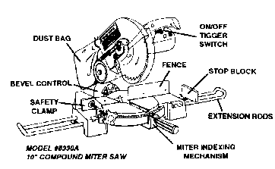
BASIC FUNCTIONS
The main function of the Miter Saw is for the quick and accurate crosscutting in hard/soft woods, plastics, and aluminum extrusions at various angles. Because of the short downward movement of the blade, this function is performed much quicker than can be accomplished on either a Table or Radial Arm Saw. Detent stops at 0', 15', 22-1/2', 30, and 45 degrees left and right, permit easy changing of commonly used angles.
The Miter provides portability from one location to another, making it ideal for out of basement projects or for contractors on the job site. It is invaluable for framing operations where 90 degree or angle cuts in 2" X 4" or 2" X 6" material is required.
Utilizing a Universal motor like the bench table saw, it has high torque for cutting power. Most Miter Saws have a built-in safety electric brake. This feature stops the turning blade once the cutting operation is completed and the trigger switch is released.
NOTE: ABRASIVE CUTOFF WHEELS SHOULD NOT BE USED ON ANY MITER SAW
COMPOUND FEATURE
The compound feature allows bevel cutting to be performed. The bevel operation can be combined with the miter angle to provide compound angles for trim or molding work. (works especially well for crown molding). Positive stops are provided at 0' and 45 degrees, with a bevel indicator scale for angles in between. Accurate cutting can be performed on picture frames, baseboard moldings, door/window framing, chair rails, etc.
SLIDE COMPOUND FEATURES
Slide Compound Miter Saw provides all the features found in regular and compound miter saws. In addition, it allows for extended crosscuts up to 12" inches in width. Instead of just a downward movement, the motor assembly rides on ball bearings mounted on precision ground shafts. To operate, the blade is brought forward to the maximum required distance and lowered. The blade/motor assembly is then pushed in a slow and steady action back through the workpiece, until the cut is completed.
ACCESSORIES
Besides the purchase of a carbide tipped blade for miter saws, there are other accessories that greatly increase its performance. For finishing projects such as trim/molding, etc. a planer blade (hollow ground) or a 60- tooth carbide is recommended. This will provide the smooth, even cuts required in finished projects like cabinet or furniture making,
SAFETY CLAMP
Used for clamping the workpiece to the fence and table, it provides safety to the operator especially when crosscutting any workpiece less than 6" in length (as measured from the blade). All cuts must always be clamped and never held by hand.
EXTENSIONS WINGS / STOP BLOCK
Extension wings, used on both sides of the worktable, provide extra support for long work pieces. An adjustable stop block that can be located on the right or left side extension wing, is used for repetitive cuts.

