Week Three Notes

BAND SAWS
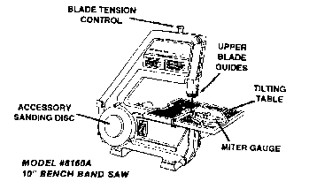
BASIC FUNCTIONS
The Band Saw again like the Scroll Saw, is used primarily for cutting of curved or shaping pieces of wood. Use of the miter gauge or tilting of the work table adds versatility to this task.
Another important function of a Band Saw is its ability to resaw or rip narrow pieces of wood safer than with a Table Saw. The work table is slotted for use with a Miter Gauge that increases the accuracy of straight cuts. Because the table also tilts, the band saw will do ripping and crosscutting at angles up to 45 degrees.

BLADES
Blade selection for the Band Saw requires consideration.
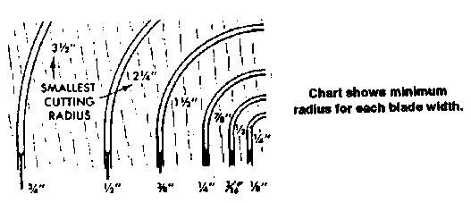
The length of the blade is the first consideration. Most manufacturers, have standardized blade lengths. When this is determined, the width is the next consideration.
There are various width blades for different cutting jobs. Naturally, you would use a narrow blade for sharp curves and a wider blade for straight or wide curves. As in the Table Saw, the fewer teeth per inch are a good free cutting general purpose blade.
Follow these suggestions when choosing a blade: Choose one for the sharpest curve you intend to make. Always use the widest blade that will do the job. On straight cuts, use your widest blade.
The Band Saw will give a smooth, even cut because of its continuous downward stroke. Operating the Band Saw is similar to the Jig/Scroll Saw. The workpiece must be fed with an even, gentle pressure, never forcing faster than the blade cuts. The unit will handle straight or curved work of almost any shape where the pattern is sawed through.
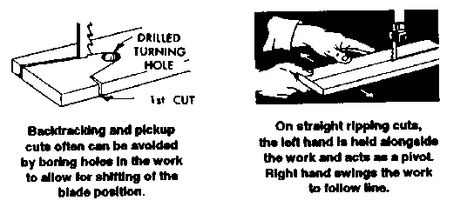
Cut sharp curves with a series of tangent cuts. It is often more practical to turn and cut through waste stock rather than pull back. Shape curves often may be cut easily by first drilling a hole near the turn. (See illustration) Square corners are cut out by first cutting a radius, then returning to saw out corner from each side. Get the feel of the blade with a few practice cuts. don't force work against the blade in excess of the cutting capacity.
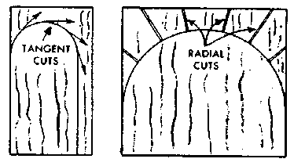
FOLDING BAND SAW BLADES
It is a simple matter to fold band saw blades into small spiral of thirds, if you follow these instructions. Always hold blade firmly and don't let it twist in your hand while folding.
Teeth are toward you - position shown in illustration, Twist with arrows and keep folding through, gradually moving hands closer together, until blade flops into spiral. If you fail on the first try keep at it - suddenly it will come to you.
Use caution so you don't cut your fingers or kink the blade.
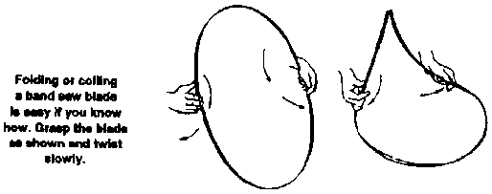

BELT/DISC SANDERS
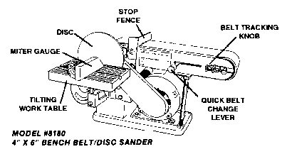
BASIC FUNCTIONS
The Belt Sander functions in various ways. The belt can be used at either a 0 degree horizontal or 90 degree vertical angle. The belt is supported by a steel table surface at 0 degrees for flat sanding. When the machine is tilted up to 90 degrees, the unsupported underside of the belt works well for curved pieces.
The sanding disc moves at the same time as the belt, and has a side work table that can be tilted from 0' to 45 degrees for bevel sanding. Most units have a miter gauge, which when used allow for end grain miter or compound sanding operations. This side table can also be moved to the end of the sanding belt for additional work support when the machine is in the 90 degree upright position.
SANDING BELTS AND DISCS
The abrasive used on your belt and disc sander depends upon the work that you wish to sand. For most woodworking operations on soft woods, garnet belts and discs are used. However, on hard woods, aluminum oxide belts and discs are usually preferred.
Both aluminum oxide and silicon carbide are used for sanding metal. Aluminum oxide is used for sanding metals of high tensile strength, whereas silicon carbide is recommended for metals of low tensile strength.
For miscellaneous work on glass, porcelain, tile, stone, composition and rubber, use silicon carbide abrasive belts and discs.
When sanding plastics, either aluminum oxide or silicon carbide may be used.
Since the work done on the sander belt is of general nature, it is usually best to use a (80-0) grit sander belt. The disc sander is mostly used for edging operations and therefore you should use a coarser abrasive, usually an (80- 0) or (60-1/2) grit. Where fine cabinet work is being done it is always best to use (120-3/0) or (100-2/0) for the final sanding operation. In general abrasives are classified as follows:
FINE: (1 50-4/0) (120-3/0) (100-2/0)
MEDIUM: (80-0) (60-1/2) (50-1)
COARSE: (40-1-1/2) (36-2)

