Week Four Notes

THICKNESS PLANERS
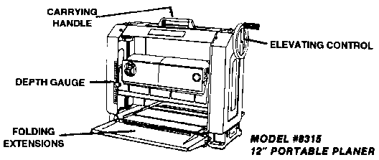
The planer can also be used to square-up old or rough lumber and remove old paint from woodwork. It is an essential tool for the tradesman in the construction of cabinets or furniture making.

SHAPERS
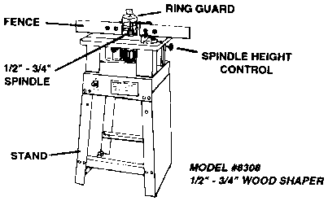
In the workshop the shaper is used for straight and irregular shaping, matched shaping, tonguing and grooving, fluting and decorative molding. It is simple to operate and does superior work quickly and accurately. High speed is an important factor in assuring clean cutting performance on any shaper.
When preparing the shaper for use, use a cloth soaked in kerosene to remove any pitch build up on the edge of the knife. Fasten the fence and lock in position. The shaper, if possible, should be set up in a central location in the workshop, as the length of the work that it can handle is limited by the distance from the spindle to the walls or other machines. The cutter must be put on to the spindle so that the cutting edge faces in the direction of rotation. A thin coat of paste wax will keep the ground table surface free from rust. This is a recommended practice on all cast iron ground surfaces.
Straight shaping is the process of cutting a profile or contour on the straight edges of table tops, or cutting molding on straight lumber. To align the fence for straight shaping, place a straight edge against the left side and move the right side up to this straight edge and fasten.
Irregular shaping is the process of shaping the irregular edges of oval shaped tables, curved legs, table stretchers and decorative moldings on all types of curved, irregular edges. For irregular shaping, remove the fence and replace with the proper depth collar for the depth of cut to be made. A ring guard should always be used when shaping curved work directly against collars. Besides offering protection, the guard provides a hold-down by pressing the work down on the table surface.
Matched shaping is used in the construction of cabinets, interior trim, and similar work. A pair of matched cutters is used; one to cut the female portion of the molding forming the joint, and the other to cut the male portion. Best known examples are tongue and groove or drop-leaf cuts.
All shaper cutters must be kept as sharp as possible. A flat, oil stone, about 2" X 6", and a slip stone of the same material is recommended. To renew the edge, no great amount of metal need ever be removed at any one time and the cutting angle of the edge should be changed as little as possible. Carbide tipped cutters are also available. These should be resharpened by a professional.

JOINTERS
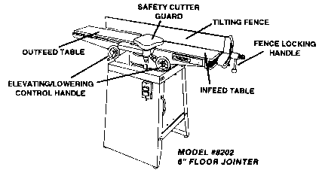
The term jointer comes from the operation of making straight, smooth edges on two pieces of lumber so they can be glued together (or joined) to form table tops, etc. You can also cut a step or rabbet in a piece of lumber along the edge, parallel to the grain. A rabbet can be cut in one side of a board as is used for raised panel doors. By tilting the fence, you can bevel the edge.
The jointer operates on the principle of a rotary cutter revolving at high speed. The front of the jointer is adjustable so that it may be changed for various depths of cut. The rear table is set parallel with the front table. The step between the front table and the rear table determines the depth of cut. The machine is equipped with a scale and indicator for reading directly the distance of the step from the front to the rear table.
When the depth of cut is set, a piece of lumber is passed over the front table, through the cutter knives and onto the rear support table.
OPERATION
There are three basic cutting operations that can be made on a jointer.
A) Jointing the edge of a piece of wood is most common.
B) Surfacing or face planing may be also done with good results.
C) Rabbeting is a step cut on the face or edge of a board. The section of the front table that protrudes out toward the rear table is used to support the uncut section of the board after it passes through the cutters. This is called a rabbet ledge or table. Rabbeting can only be done with the front guard removed. REMEMBER TO REPLACE THE GUARD AFTER THIS OPERATION.
To operate the machine, you must set it up for the desired depth of cut, the angle of the cut, and, in the case of a rabbet cut, the width of the cut. The depth of the cut is determined by the step distance between the front and rear tables. The width of the cut is determined by the location of the fence guide from the front edge of the jointer knife. The angle of the cut is determined by the angle set on the fence guide. Important factors in determining the depth of cut would be the width and the hardness of the material. For instance, to cut a piece of hard maple almost the full width of the cutter head, set the table somewhere between 1/64" and 1/32" for best results. To remove 1/4" material from a board of this size would require several passes through the machine until you have reached your desired thickness. A much deeper cut could be made on 1/2" wide piece of soft pine. For fine finishes, a thin cut will give the best results. The table is adjusted by turning the elevating knob handle counter-clockwise to lower and clockwise to raise
The fence of the machine has two movements (1) it can be titled from 90 to 45 degrees closed and from 90' to 45 degrees open for a bevel cut. (2) It can be moved from the front to the back of the machine for locating various widths of rabbet cuts.
When cutting a board, you must always use a pusher block. NEVER PLACE YOUR HAND DIRECTLY OVER THE CUTTER KNIVES. Feed the work with a slow even pressure on the front table until it engages in the cutter knives. Use your right hand and pusher block to hold the work firmly down on the front table. When the work reaches the rear table, lift your left hand across and hold the work firmly down on the rear table and against the fence until the entire piece is pushed through the cutter head. When cutting boards over three feet in length, the most uniform cut will be maintained by supporting the board at table height after it leaves the rear table. Warped boards should be cut on the concave side for best results. To avoid pitting or torn grain, operator should, whenever possible, determine which way the grain emerges from the board. The board should be fed through the machine with the grain pointing downward and towards the front of the jointer.

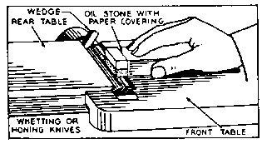
SHARPENING THE KNIVES
Knives should be honed occasionally with a fine abrasive stone to retouch the edge. First, disconnect the unit from the power source. It is not necessary to remove the cutter knifes out of the cutter head; simply put a wooden wedge between the cutter head and the table so that it will hold the knife firmly and at the proper angle. Adjust the front table so that the stone pressed lightly against the full width of the knife bevel. To remove the burr on the flat side of the knife, use a fine slip stone or a piece of emery cloth.
REMOVING AND RESETTING KNIVES
Disconnect the unit from the power source. The knives are held into the cutter head by three set screws. To remove the knives, loosen these screws and slide them out of the slot. Once the knives have been reground, they will have to be set back in the cutter head and readjusted for height and radially in line on the side toward the rabbet table. Note, in the bottom of each slot, there is a screw that may be backed out or turned in to raise or lower the knife. This should be done on each end of the knife checking to see that it is perfectly even with the surface of the rear table. Once the height is set, the knife should be tightened securely with the three locking screws. To locate them radially in line against the rabbet ledge, a block can be clamped to the rabbet ledge and slide each knife out to it. Be sure the knives will clear the opening between the tables. Turn them through by hand, slowly, after each setting.

