Week Five Notes

LATHES
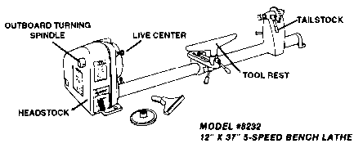
Wood turning on the lathe is the most fascinating of all power tool operations. It is amazing to see the interesting designs possible with hardly any effort the first time you use a lathe. Besides spinning beautiful objects the lathe is a versatile utility tool. It can be adapted to boring, routing, sawing, polishing, sanding, etc.
ADJUSTING THE TOOL REST
To adjust the tool rest, first loosen the tool rest post clamp and set the top of the tool rest approximately 3/8" above the center line of your work. Never set the top of the tool rest below the center line of the workpiece being turned. Next line up the top edge of the tool rest parallel to the piece being turned
and about 1/8" away from the farthest projecting edge of the stock. DO NOT TRY ADJUSTING TOOL REST WHILE THE LATHE IS RUNNING. Be sure to turn work by hand to make sure that it has sufficient clearance before turning on the electric power.
POSlTlON OF OPERATOR
Operator should stand in a natural position in front of the lathe, with the left side of the body turned slightly nearer the the than the right side. Operator should dress properly to eliminate the possibility of long sleeves, neckties, long hair or other hose clothing getting caught in the revolving stock.
TURNING OPERATION
When turning stock under 3" square, place the "V" belt on the largest pulley setting on the headstock. Run the lathe on this low speed until all roughing cuts has been made and the stock is cylindrical in form. In general, all roughing cuts should be made at low speeds.
WOOD TURNING TOOLS
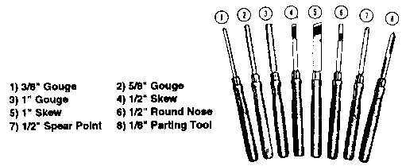
When using a Gouge Chisel the round side of the gouge should rest on the tool rest and should be turned or rolled a little to the right, always holding the wooden handle down. After the roughing cut has been made, be sure to readjust the tool rest so that it is 1/8" away from the cylinder and tighten in this position.
The "Parting Tool" is used to cut narrow grooves to serve as depth guides to facilitate the turning of a true cylinder. The parting tool may also be used for squaring or cutting off the ends of the cylinder to the proper length. The parting tool should be held with the narrow edge on the tool rest with the point of the tool above the center line.
The "Round Nose Chisel" is used for concave cutting. Place the round-nose chisel flat on the tool rest with the bevel side of the chisel down.
The "Square Nose Chisel" is used for smoothing off the cylinder and making it perfectly straight just before the sanding operation. Hold the chisel with the beveled side down.
The "Diamond Point Chisel" is generally used for convex or head cutting where it is necessary to round off corners. The diamond-point chisel should be held with the beveled side resting on the tool rest.
The "Skew" is used for smoothing the cylinder. Lie the large skew on the tool rest with the cutting edge above the cylinder and at an angle of 60 to the surface of the cylinder. To start the cut, draw the chisel back slowly towards you and raise the handle until the chisel begins to cut at a point approximately 1/4" from the heel. The skew may also be used for rounding off corners.

BENCH GRINDERS
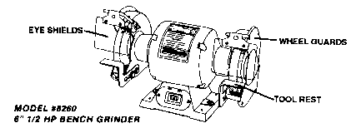
Descriptions for bench grinders are based on two features:
1. The diameter of their grinding wheels, whether 5", 6", 8" or 10". Both wheels that come standard with the unit are the same diameter, but have different grits (medium/coarse).
The main accessory used on a Grinder is a Wire Wheel. These allow for the quick removal of paint or rust without removing much of the main surface. Wire wheels or buffing wheels add additional functions to the use of a Grinder. They are used in place of one of the grinding wheels. A wire wheel must be the same size as the grinding wheel: 5", 6", or 8".

