**Tuesday,January 27th, 2015 is Family Literacy Day! PCS would like to invite Moms, Dads, Grandmas, Grandpas, Sisters and Brothers of our K-5 students to come along to our:**

**Come Listen to Me Read Day!!!!**

**A time for your elementary child to read their “just right” books to you!!**

C:\Users\heather.allaby\AppData\Local\Microsoft\Windows\Temporary Internet Files\Content.IE5\R7T586BP\MC900056930[1].wmf

**When: Friday, January 30th**

**Where: K-5 PCS Gym 1:00-1:30pm**

(Please enter through Learning Garden Doors.)

What a great way to show your child how we all work together to support their learning!!!

***\*If you are unable to attend K-5 “Come Listen to Me Read Day”, please let your child’s homeroom teacher know and we will have an older student listen to them read so they will not be left out.***

***[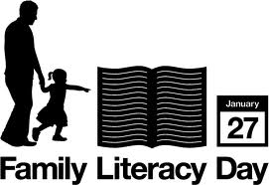](http://www.google.ca/imgres?q=family+literacy+day&hl=en&safe=active&biw=1366&bih=587&gbv=2&tbm=isch&tbnid=yvJbq052HwfBKM:&imgrefurl=http://kids.tbpl.ca/article/family-literacy-day-146.asp&docid=hkYOFwQgZo7r_M&imgurl=http://kids.tbpl.ca/upload/images/fldlogo_eng.jpg&w=479&h=329&ei=i78WT_nNLMGrgweUr8nSAw&zoom=1) For more Family activities visit;*** [***http://abclifeliteracy.ca/fld/family-literacy-day***](http://abclifeliteracy.ca/fld/family-literacy-day)