**Family Literacy Day will take place next week! PCS would like to invite Moms, Dads, Grandmas, Grandpas, Sisters and Brothers of our grades6-8 students to come along to our:**

**Come Listen to Me Share My Writing Day!!!!**

**A time for your Middle Schooler to read a piece of their own writing to you!!**

C:\Users\heather.allaby\AppData\Local\Microsoft\Windows\Temporary Internet Files\Content.IE5\R7T586BP\MC900056930[1].wmf

When: **Wednesday, January 28th**

Where: **PCS Gym 1-130** Please enter through the Learning Garden Doors beside the gym

What a great way to show your child how we all work together to support their learning!!!

***\*If you are unable to attend 6-8 “Come Listen to Me Share My Writing Day”, please let your son/daughter’s homeroom teacher know and we will have an another student listen to them share their writing so they will not be left out.***

***[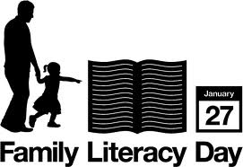](http://www.google.ca/imgres?q=family+literacy+day&hl=en&safe=active&biw=1366&bih=587&gbv=2&tbm=isch&tbnid=yvJbq052HwfBKM:&imgrefurl=http://kids.tbpl.ca/article/family-literacy-day-146.asp&docid=hkYOFwQgZo7r_M&imgurl=http://kids.tbpl.ca/upload/images/fldlogo_eng.jpg&w=479&h=329&ei=i78WT_nNLMGrgweUr8nSAw&zoom=1) For more Family activities visit;*** [***http://abclifeliteracy.ca/fld/family-literacy-day***](http://abclifeliteracy.ca/fld/family-literacy-day)