WELCOME
TO
PRINCE CHARLES
SCHOOL
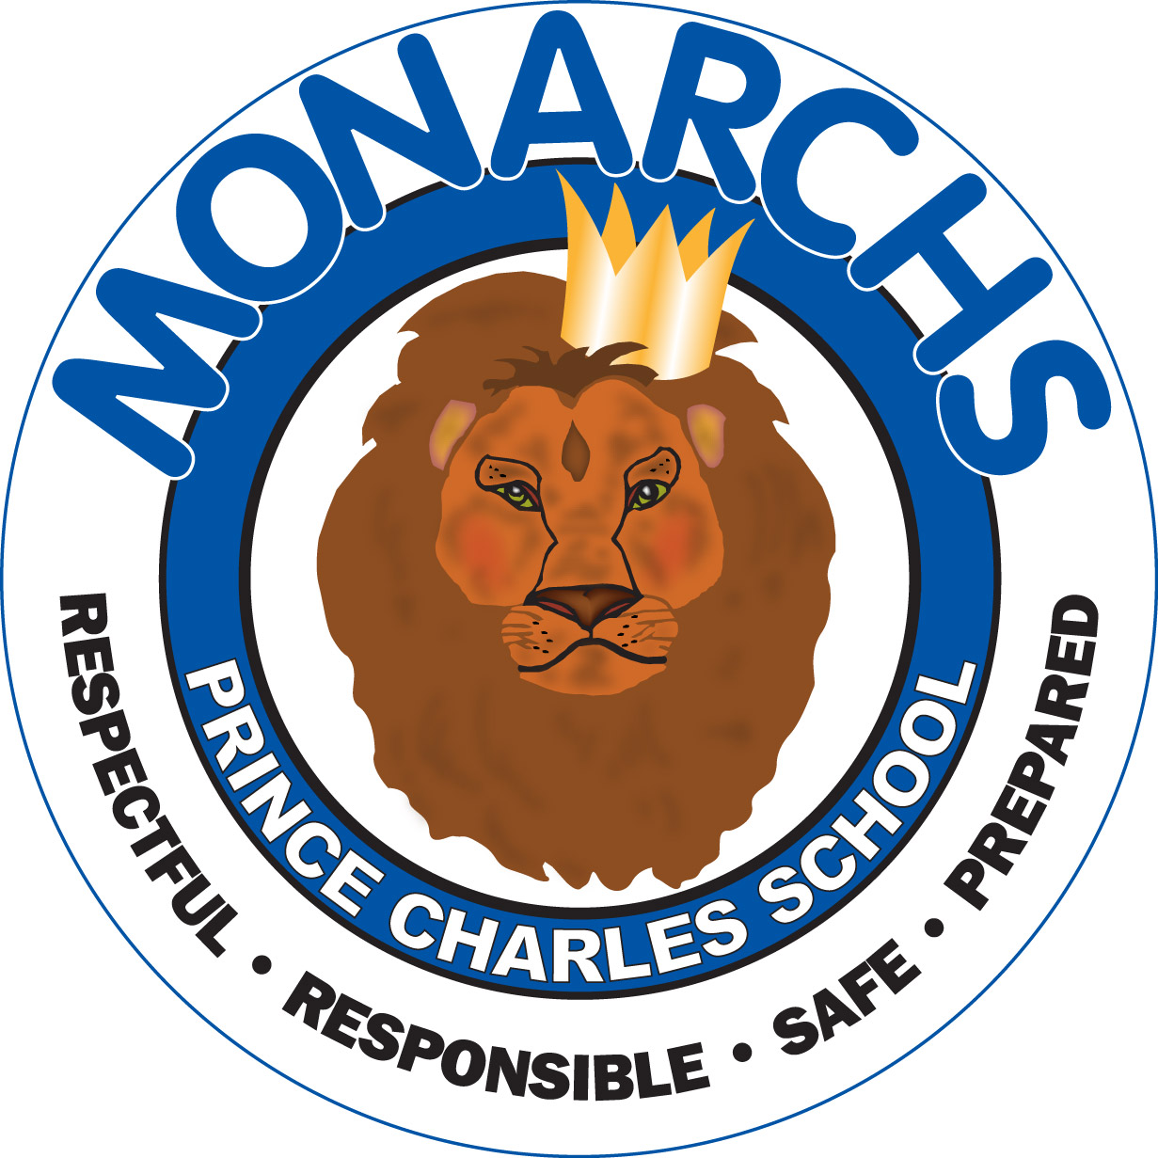
2016-2017
“MISSON STATEMENT”
Our School Community believes Prince Charles School is a welcoming and safe community school with high academic and behavior expectations for each student.
Each student is required to be Responsible, Respectful, Safe, and Prepared in our Positive Learning Environment.
We will all work together to ensure each student experiences success.

We all embrace our-CODE OF CONDUCT
I AM A MONARCH, THEREFORE I AM…
RESPONSIBLE, RESPECTFUL
SAFE, PREPARED
As a Monarch I must use appropriate language, therefore I will always use:-Polite language--A respectful voice level--A respectful tone
As a Monarch I must dress in an appropriate way, therefore I will always:
- Remove my outdoor wear during instruction
- Wear modest clothing free of offensive language
- Dressing appropriately does not include my;
  - Allowing my undergarments to show
  - Wearing shirts that show my midriff
  - Wearing tank tops, pajama pants or shirts with spaghetti straps
  - Wearing offensive clothing, headgear, or ball caps
REMINDERS;
- All personal belongings are to be labeled to assist in identifying lost items.
- When students are in the playground they are to remain in view of the outdoor supervisor.
- If there is any change to a student’s daily routine parents/guardians must notify the school in advance in writing (lunchroom, dismissal).
- It is compulsory that all students wear some type of shoes at all times, in case of fire drills or emergencies. This is especially true in winter when boots are worn to school and must be removed before entering the classroom.
- If you are assigned a locker, you may only use it before homeroom, during break, during lunch and after school.
- As a sign of respect and courtesy we all will remove our hats when entering the school.
- It is expected that we all show respect toward each other; teachers, school staff and guests.
- Students are asked not to arrive before 8:10am, and to enter and exit using the appropriate doors.
- Students are expected to be on time and attend school daily. For safety reasons, it is requested that parents/guardians notify the school by phone (leave message) early on the day of a student’s absence. (658-5355)
- When a student returns to school, a note from a parent or guardian should accompany the student explaining the absence.
- Electronics remain at home-unless requested by teachers
- We must all conduct ourselves in such a way that supports a Positive Learning and Working Environment.
- Students may bring a water bottles in class during instructional time
- Parents & guests are asked to report to the office sign when coming into the building. We also ask that parents meet their child outside at the back door entrance at dismissal time.
- K-2 children should be dropped off & picked up by an adult.
- NUT AND SCENT FREE- We have several serious allergies in the building and as a result must be scent and nut free. Since the resemblance to peanut butter might cause anxiety and confusion, peanut butter substitutes, like WOW butter must be clearly labelled with the stickers that come with the product. We also are asking that parents not send any food into the school to share with the class- cupcakes, birthday cakes, treats etc cause safety issues in the classrooms and in order to be inclusive we do not wish to serve things that not all our children can eat. Special pencils, erasers, stickers etc can be sent in on special occasions to share with everyone safely.
- No smoking on school grounds.
- Listen to announcements and watch for notices regarding ALL our many activities!

DAILY SCHEDULE
8:00 Students come in for Breakfast Program
8:10 Teachers in rooms to receive children
8:30 Classes begin
10:15 – 10:30 Nutrition Break
12:00 Dismissal for lunch
12:40 Students come in from yard
12:45 Classes start
1:45 K – 2 Dismissal
2:45 3 – 8 Dismissal
-------------------------------------------------------------------------------------------Please return bottom portion.
I have reviewed the PCS Handbook with my child.
Parent’s signature ____________________
Student’s signature ____________________

