|  |  |  |  |  |
| --- | --- | --- | --- | --- |
| **TAKE HOME BRUNCH FOR MARCH 20TH** | | | | |
| **Muffins** | Chocolate Chip | Apple Cinnamon | Banana Chocolate Chip |  |
| **Bagels** | Plain | Cinnamon Raisin |  |  |
| **Subs** | Meat Trio & Cheese | Veggie |  |  |
| **Condiments** | Mayo | Mustard | Cream Cheese | Jams |
| **Fruits** | Apples | Bananas | Cucumbers | Grapes |
| **Special Treats** | Sugar Donuts | Plain Donuts | Yogurt | Various snacks |

**CHILDREN’S LESSONS THIS WEEK:**

**Grade 1-** Introduction to Manners   
**Grade 2-** Introduction to Feelings- Fine, Excited, & Calm  
**Grade 3-** Feelings Intensity   
**Bee Me Leaderz-** Role Models

**CHILDREN’S ACTIVITY THIS WEEK:**

**EGG DROP CHALLENGE**

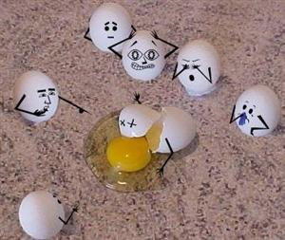

**2020/2021 SCHEDULE:**

To register:  
Download the **Bee Me Kidz app and click “weekly sign up”**   
 OR call   
Sheila @ 654-1395 (NORTH)  
Saige @ 654-1377 (EAST)