Week of May 19th – 22nd – “Balancing”
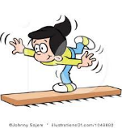
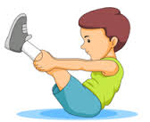
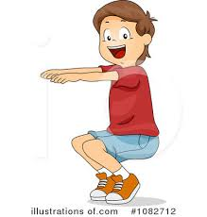
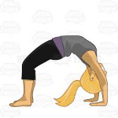
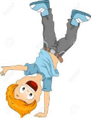
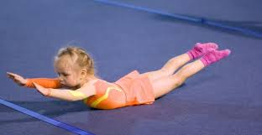
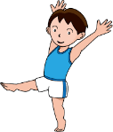
This week theme is "Static Balancing" - for 20 -30 minutes each day practice/play games using some of the balances below.
Skill Cues | Description
Static Balance
Be still | Maintains a steady balance
Aeroplane Wings | Uses arms to maintain balance
Knees Bent | Lowers body, bends knees
Wide Base | Widens base of support
Look Forward | Focuses eyes forward
Hold | Holds position for 3-5 seconds
Balance on One Foot (i.e.: Stork Stance)
Move | Maintains balance while using alternate stepping action
Good Posture | Maintains an upright posture, head still, standing straight (back in neutral position)
Aeroplane Wings | Maintains balance using arms as needed
Look Forward | Focuses eyes forward or on a target
Foot flat against leg | Places sole of foot (non-support leg) against inside of knee and thigh of support foot
Other foot flat on the ground | Places support foot flat on the ground
Games: Please check out You Tube videos called:
“Rock Paper Scissors Static Challenge” – game can be played for points or just fun practice. Get a few friends, family members to join in. Use a soft surface ie: grass, mats, carpet, etc.
“Dead Ant Continuation Tag” – If you can get a group together. This game would be fun! Take some cones to set up a boundary area.

