YIP June Calendar of Events
Drop In – Every day after school 3-4:30pm @ LMS,Monday and Wednesday supper served at 4:30pm.

Gurl World – Summer Blitz Mondays 5-7pm @ LMS

Hanging With the Guys –Fellas from North and East Mondays 5-7pm @ LMS

One Teen Fit – Challenge yourself! 5-7pm Wednesdays @LMS

Youth Council –Thursday , June 16th 5-6pm @ NECC

Special Events – Stay Posted For Our 8 Week Summer Program.

HWG=Hanging With the Guys
GW= Gurl World
LMS=Lorne Middle School
NECC= North End Community Centre
*If you have any question contact Jeremy at the Y.I.P @ 657-2408*
Sunday | Monday | Tuesday | Wednesday | Thursday | Friday | Saturday
 |  |  | 1st Cooking  ONE Teen Fit | 2nd Wii Day | 3rd Animal Rescue league | 4th
5th | 6th GW/HWG | 7th Gym Activities | 8th Cooking  ONE Teen Fit | 9th Wii Day  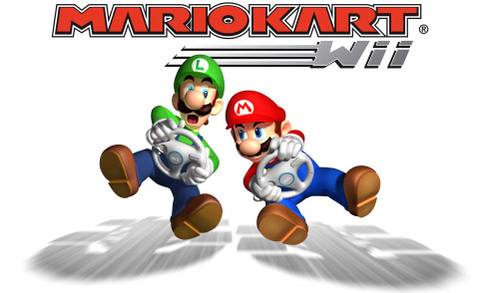 | 10th  Animal Rescue league | 11th
12th | 13th GW/HWG | 14th Gym Activities | 15th Cooking  ONE Teen Fit | 16th Wii Day | 17th  Animal Rescue league | 18th
19th | 20th GW/HWG | 21st gym activities | 22nd Cooking  ONE Teen Fit | 23rd Wii Day | 24th  Last day of school  PARTY | 25th
26th | 27th | 28th | 29th | 30th

