Date: Friday, Feb.24
I love my
SWAG

Time: 7-9pm
Place: North End Community Centre

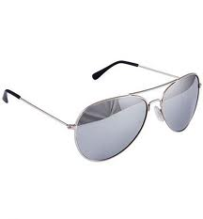

Come dressed like you have serious swag. Baggy hoodies, hats, cool kicks, serious shades and bling. Whatever you have hanging around your house that makes you feel cool, put it on and come enjoy the dance. There is going to be lots of good music, dancing and a canteen if you want to buy some snacks. We hope to see you out. It’s going to be a great time. BRING YOUR FRIENDS!

