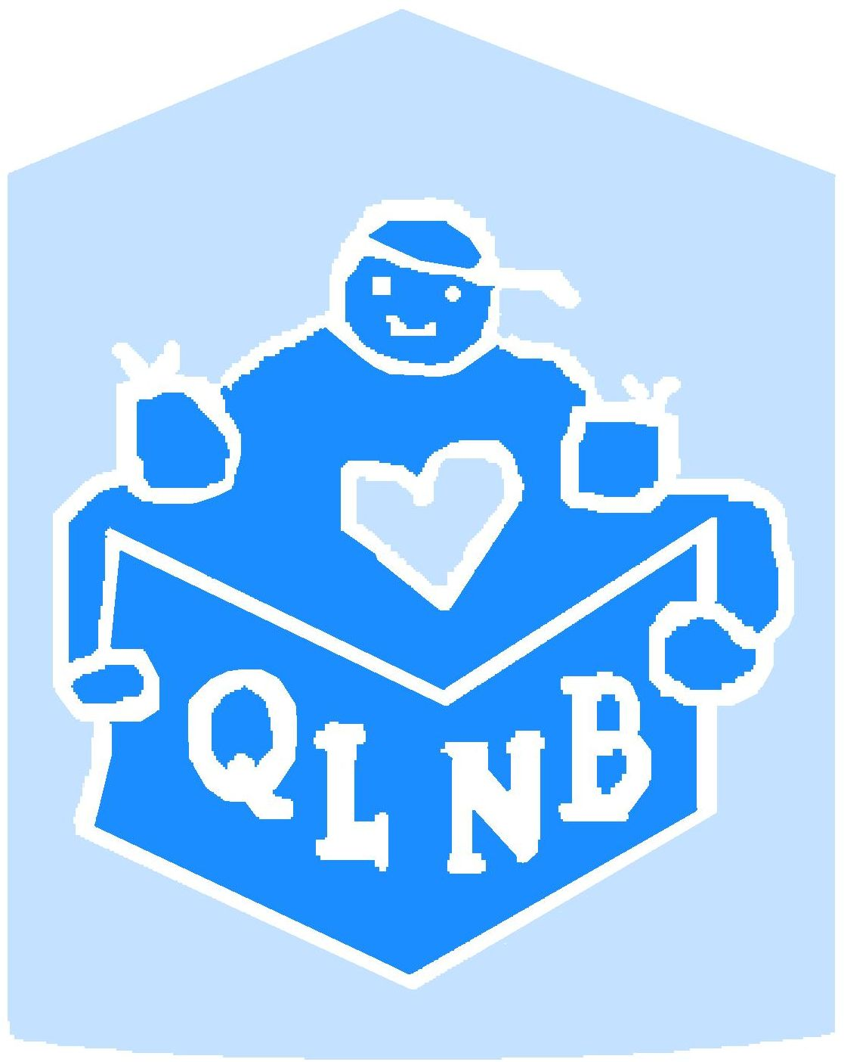
FREE Get Set Learn! Curriculum training
Thursday October 20, 2011
9:00am – 3:30 pm

Registration

Thanks for confirming your spot by email or mail before October 15, 2011

Name:

Title:

Organization:

Phone #:

Email:

Field of work:

_____________________________________________________________
Lunch is provided. Please list any dietary needs:

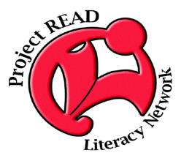
For more information please contact:
Cheryl Brown, Community Literacy Coordinator
Quality Learning NB
P. O. Box 6026, Brunswick Square
Saint John, NB
E2L 4R5
(506) 333-2601
sjfamlit@nbnet.nb.ca

