December 15, 2014

Dear Parents of Lorne Middle School:

This letter is a follow-up to notifications from your Principal, Greg Norton, about a meeting on Thursday evening, January 8th at Lorne Middle School at 7 p.m. As you are aware, the District Education Council is hosting a series of public meetings for parents regarding the sustainability of your school.

We are following Policy 409 of the Department of Education and Early Childhood, http://www.gnb.ca/0000/pol/e/409A.pdf which states that we must have three public meetings to discuss any school closure. The first meeting for Lorne Middle School was held at the school on November 18, 2014. At that meeting I outlined the process the Council must follow with Policy 409, and District staff talked about the options for Lorne Middle School. The power point used that evening can be found on the Anglophone South website at www.asd-s.nbed.nb.ca The main page has a news item entitled “School Sustainability Reviews & Public Consultations”. Click “Read More” and it is the “Proposal for School Closure and Consolidation – Lorne School.” I would encourage you to review it. If you do not have access to our website, please let the school know and we can provide a copy for you. The power point contains important information about the proposal.

Our second meeting is Thursday, January 8, 2015 at Lorne Middle School at 7:00 p.m. The purpose of this meeting is an opportunity to make a presentation to the DEC or to provide feedback on this proposal. You are also welcome to write to me at the at the above address, or you can send any comments to the following e-mail: asds.schoolreview@gnb.ca

Yours truly,

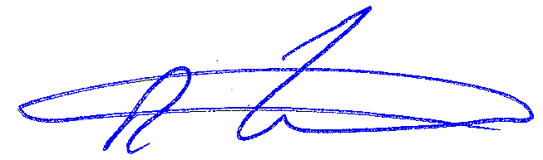

Rob Fowler, Chair

/cmm

