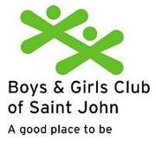OPEN HOUSE
Boys & Girls Club

634-2011 ext, 223

Boys & Girls Club

634-2011 ext, 223

Boys & Girls Club

634-2011 ext, 223

Boys & Girls Club

634-2011 ext, 223

Boys & Girls Club

634-2011 ext, 223

Boys & Girls Club

634-2011 ext, 223

Boys & Girls Club

634-2011 ext, 223

Boys & Girls Club

634-2011 ext, 223

Boys & Girls Club

634-2011 ext, 223

Boys & Girls Club

634-2011 ext, 223
Saturday, November 19th

Come and see what we have to offer!

10:00-2:00PM@ 1 Paul Harris St.
Learn about our programs:
- Day care
- Lunch
- After School
- Evening Youth
- Learning Centre
- Gym, Games, Computer, & Art Rooms
- Gold Rush
- Building Rentals and more!

*Light Refreshments & Transportation available (call for pick up schedule)

For more information contact the Boys & Girls Club: 634-2011 ext. 223

