
Lorne Middle School
Home & School Association

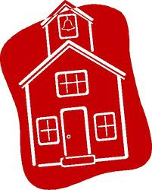
Meeting Announcement

Monday, November 21, 2011
6:30 – 7:30
At Lorne Middle School Library

We will be discussing fundraising and other topics. Enter a free draw for a Tim’s card(!)

Parents of LMS students and community members welcome.

A Home and School organization is a group of parents, school staff and interested community individuals who want to work together to support a school. Home & School organizations fundraise, plan events, and interact with parents, school and the larger community. A local Home & School is also a member of the Provincial Home & School Federation which partners with the NB Teacher’s Association and the NB Department of Education.

