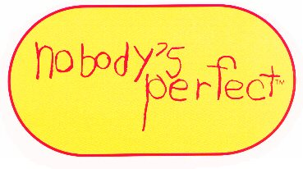
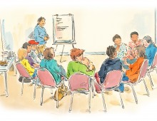
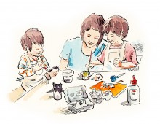

"Nobody's Perfect", is a parenting program for parents with children ages birth - 5 years.
-----------------------------------------------
Meet other parents of young children; share questions, concerns and ideas about being a parent; learn about child development, safety, health, & behaviour; discuss real-life parenting situations & discover positive ways of parenting. Build on parenting skills you have & focus on your strengths to raise happy, healthy children! :)
-----------------------------------------------
WHERE: The Family Resource Centre
211 Wentworth Street

WHAT: 6 - Week Parenting Program (Nobody's Perfect)
WHEN: Monday Evenings from 6pm-8pm
Feb. 23rd, March 2nd, 9th, 16th, 23rd, 30th
-----------------------------------------------
Childcare & Transportation support is available.
Interested?
Limited spaces / Registration Required
Contact: Karen at The Family Resource Centre 633-2182

