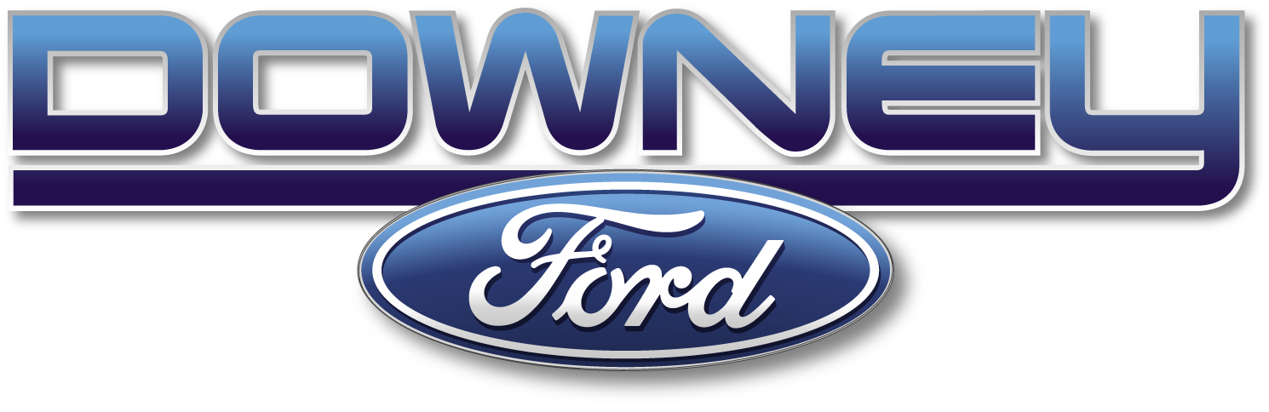

Drive One 4UR PALS School at Downey Ford

Downey Ford, Ford Canada, and McAllister Place have teamed up for the 2nd year
to support our PALS (Partners Assisting Local Schools) Schools
from the Saint John Education Centre in a fundraising event
that will have you putting “the pedal to the metal”.

Come out and Drive One 4UR PALS School!

- When?
  - Saturday October 13
  - 9 am-5 pm

- Where?
  - McAllister Place (across from Downey Ford)

- What?
  - Sign up to test drive one of the new Ford vehicles on site and Ford Canada will donate $20.00 to your PALS school and Downey Ford will donate another $20.00 to your PALS School!

- Nitty Gritty Details:
  - Drivers must be 21 years of age with valid license
  - Only 1 test drive per household
  - Each school has four 15 minute times slots an hour for you to choose from
  - There will be a suggested route to drive
  - If you are interested in supporting your PALS school contact the Principal or PALS Coordinator
  - Sorry, no Mustangs or Econo line vehicles will be available.

- And for fun!
  - BBQ of hotdogs and hamburgers and pop (no cost – donation to PALS)
  - 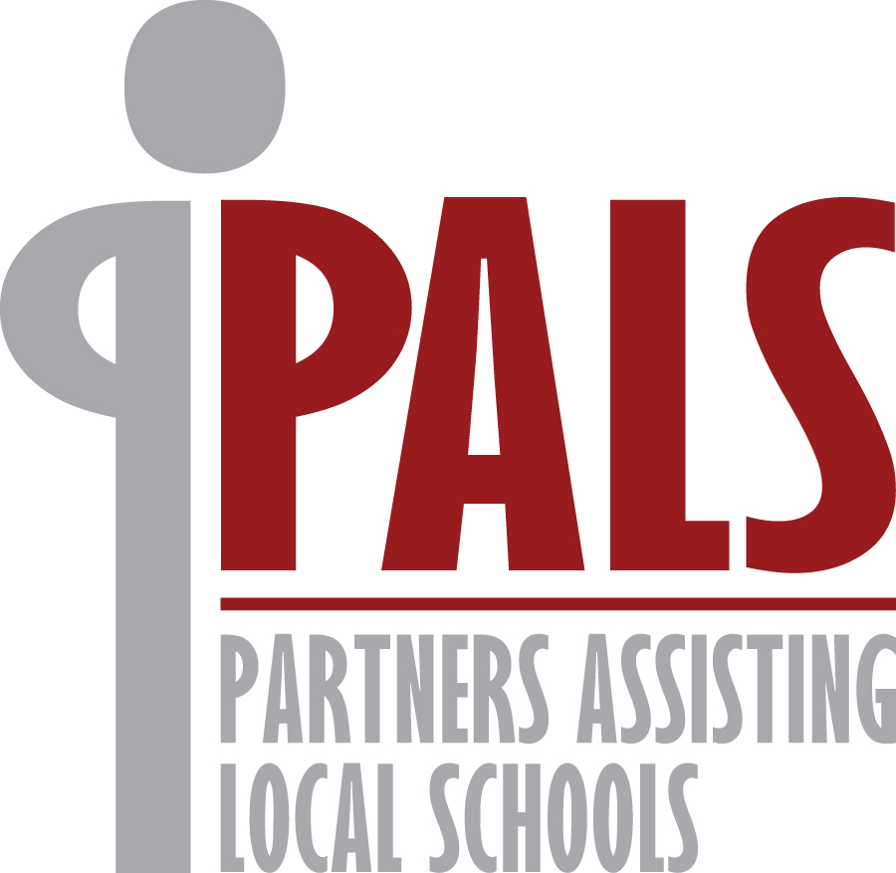Exterior Car Wash on site (no cost – donation to PALS)

A great way to support your local
PALS School while having fun doing it!!!

Hope to see you there!

