YMCA_logo_2reds_CMYK_2481.epsJoin us for a free family event designed to teach children and families about exploring healthy living habits.

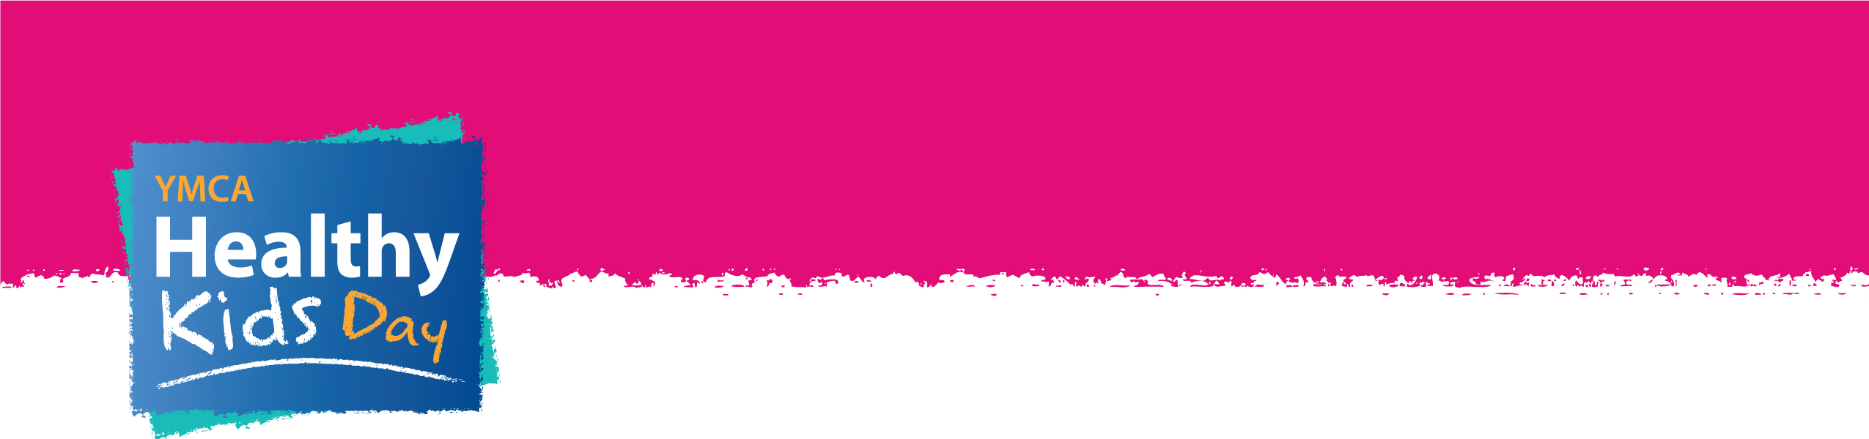

**Sunday June 3rd 2012**

**Glenn Carpenter Centre**

**10 am – 2 pm**

* Swimming
* Water Trampoline
* Canoeing
* Kayaking
* Hiking
* Summer Camp Information
* BBQ
* Archery
* Community Organizations
* Prize Draws
* Zumba
* Face Painting

For more information please visit our website at [www.SaintJohnY.com](http://www.SaintJohnY.com) or call 693-YMCA