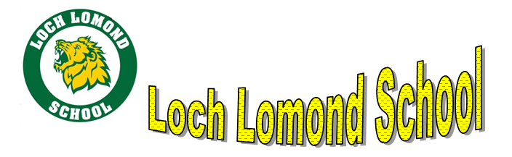
PSSC Meeting
November 21, 2023
6:00pm
Location: Innovation Lab

Mission
Our mission is to foster scholarship, leadership and responsible citizenship / Notre mission est de favoriser l’érudition, le leadership et la citoyenneté responsable.
Vision
Loch Lomond School endeavors to know each child’s strengths and challenges, and to adjust the learning to this end / Loch Lomond School s’efforce de connaître les forces et les défis de chaque enfant, et d’ajuster l’apprentissage à sur measure.

- Welcome
- Call to order
- Principal’s report
- Good for Kids (FI intervention)
The good for Kids intervention for FI will begin in January. We have been allotted money this year and the FI team has decided to hire a teacher (Rebecca Farwell) to give intervention based on student need.
- SIP focus – PBIS
Presentation describing what PBIS is. Positive behaviour interventions and supports is a way of supporting students proactively. We also reviewed behaviour data from September – December to glean why we have chosen the strategies that we have. We are focused on the creation of standard expectations, the creation of a PBIS team and the collection / analyzation of data.
- Loch Lomond Headstart and Families in need
5 families will be chosen to support. Food hampers provided by the Saint John Airport. There was discussion of registering families with the Christmas exchange, but I cannot provide this information based on RTIPPA. Families can register themselves.
- Best Seat in the House money going toward Sensory room
Discussion of whether this is benefited the whole population. These are items that are needed.

Any other items?

Next Meeting Date: January 23?

Thank you for being part of our PSSC

