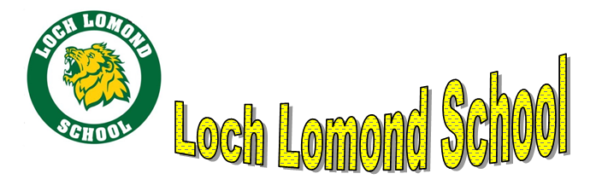

February Newsletter 2024

Upcoming Dates:

Feb. 10 Family Dance 6-8pm
Feb. 12-16 Staff Appreciation Week
Feb. 14 Valentine’s Day
Feb. 15 Flag day – dress in red and white
Feb. 16 100th Day of School
Feb. 19 Family Day – no school for Students
Feb 20 PSSC and Home and School (6 & 7 pm)
Feb. 28 Pink Shirt Day –Anti bullying Awareness
Feb. 26 – March 1 Winter Carnival
March 2-10 March Break

Staff Appreciation

Staff Appreciation Week is a perfect time to celebrate our staff’s hard work and dedication during the school year. There are many ways to show appreciation, and if you wish to write a letter, give a card, or a flower, just know that the staff would relish it. Simple is always best - if you choose to give. Thank you in advance.

ROAR Awards

Roar awards are based on our Loch Lomond Mission and Vision statements and our Behaviour / Academic codes of conduct
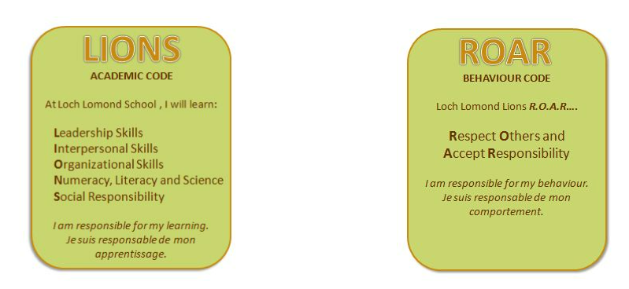
Here is a List of our monthly awards:
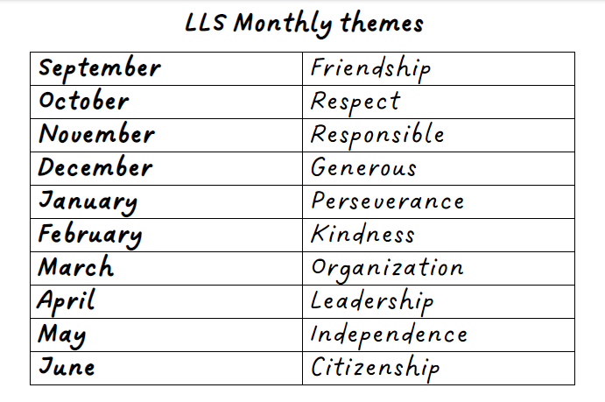

All students can receive ballots to win prizes at the beginning of every week. A copy also goes home to parents for extra praise and recognition.


Your child’s teacher will send home information regarding this fun day. Classroom numbers will be sent home but not names due to RTIPPA.

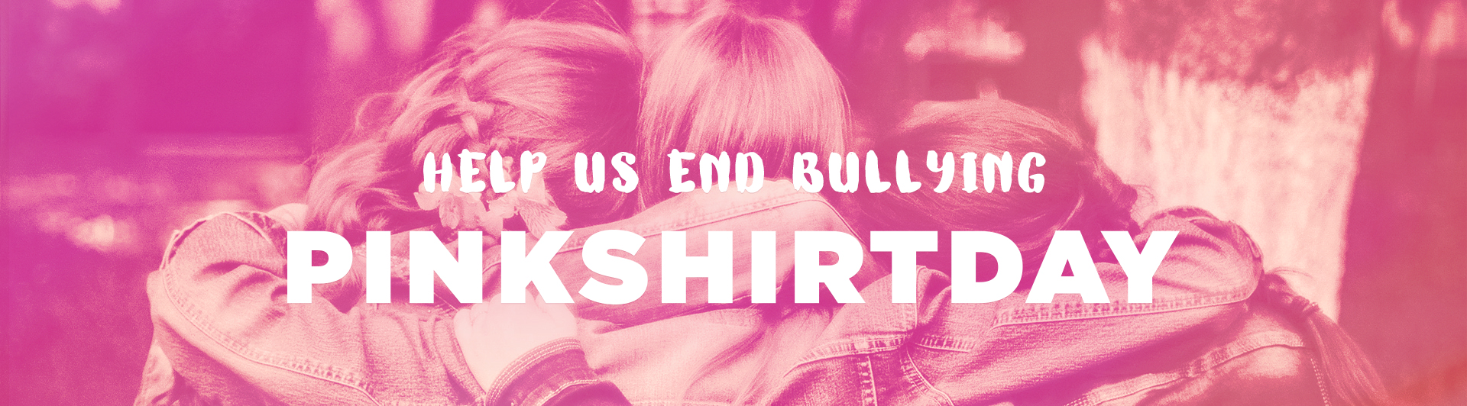

In support of Anti-Bullying Day we are asking students to wear “pink t-shirts” on February 28th.
Bullying can be a problem in our schools, workplaces, homes, and over the Internet. Please talk
about this with your children and support the cause.

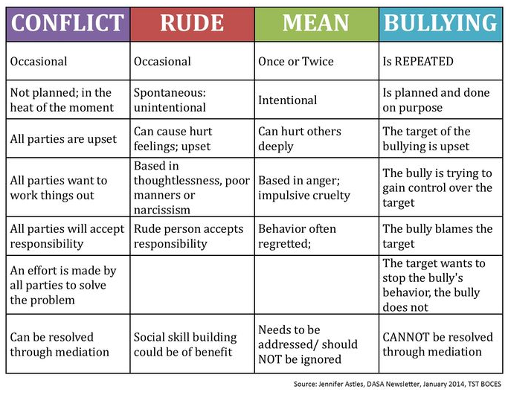

Winter Carnival Activities

For the week of Feb. 26th – March 1st. We will be celebrating “Winter Carnival Week.” We always have something fun scheduled for every day! There will be more information to come.
Monday TBA
Tuesday TBA
Wednesday Pink shirt and Pancake Day
Thursday Maple Syrup surprise
Friday TBA

Social Emotional Learning

Our school is committed to ensuring that all students get through their school years not only with strong academic skills but also with the skills necessary to foster resiliency and prevent social, emotional, and behavioral problems that can impact success in various areas of a student’s life.

We will be including Social Emotional learning activities (like the Zones of Regulation – understanding our emotions) to existing curriculum; designed to build resiliency skills by teaching students how to handle typical life stressors and difficult, but common, social situations in a positive manner.

