Before exams:  Study Strategy ü  Completing readings  Taking notes from readings  Reviewing notes from readings  Video tutorials  Taking class notes  Creating a personal study guide  Study from study guides  Attending tutoring/extra help  Forming a study group  Predicting test questions  Concept-mapping or diagramming  Reviewing old homework/assignments  Reviewing past quizzes & tests  Completing practice problems from review sheets  Studying from flashcards  Other:  Who I plan on studying with: ______________  What info I should study most: ____________  Time of day I study best: _________________  Length of study sessions: _________________  I plan on studying ____days in advance  I will put my phone ___________ during my study sessions. | 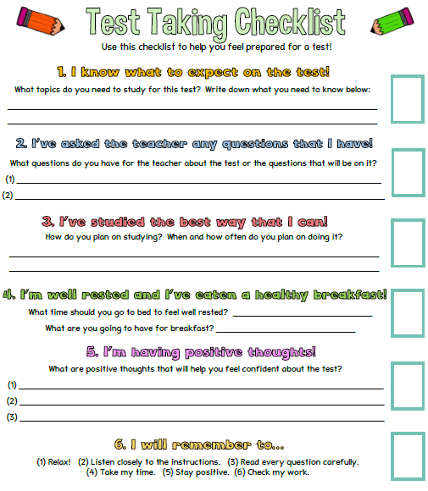
Things I need to consider when making my study plan:
- Work | - Extra-curricular | - Sports
- Religious commitments | - Family commitments | - Social activities
- My exam schedule | - Transportation needs | - Other
Use the calendar to help you develop your study plan. Pencil in your exam times and all other commitments.
Sunday | Monday | Tuesday | Wednesday | Thursday | Friday | Saturday
 | 9 | 10 | 11 | 12 | 13 | 14
15 | 16 | 17 | 18 | 19 | 20 | 21
22 | 23 | 24 | 25 | 26 | 27

