Glen Falls School Improvement Plan 2016-2020

ASD-S
10 Princess Court, Saint John, NB

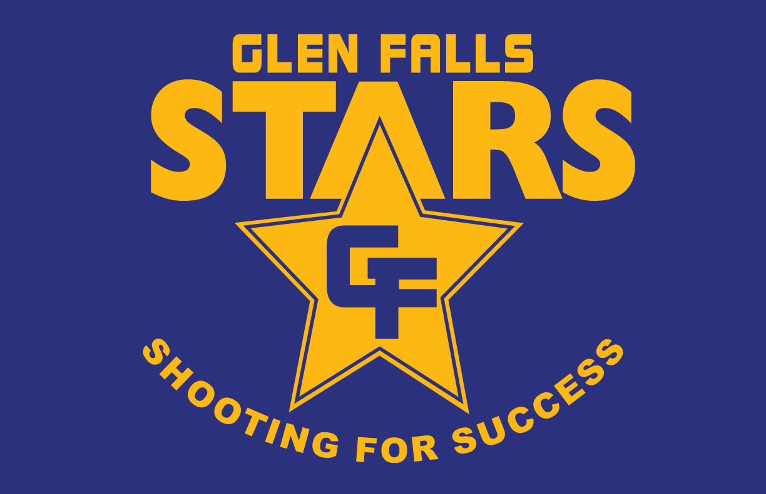
Jan. 2018

Ends Policy 1: To demonstrate continuous progress toward provincial targets in literacy, numeracy, and science (English)
GOAL | Strategies | Timeline | Indicators of success
1.1 Support classroom teachers and teams in developing and implementing routine formative assessment practices to inform both short and long-term planning based on data from ongoing assessment (classroom formative, common, school/district/provincial) | - Priority Development Unit targets will be met with the use of Literacy and Numeracy Leads  - Balanced Needs Assessment for teachers in both Literacy and Math  - Writing monthly Benchmarks  - Math Benchmarks for the PDU  - K-2 Literacy Intervention (.5)  - ELF Program  - Monthly Math Assessments  - Math Olympics  - Science – Hands on activities, field trips, websites, and presenters.  - UNB Science Boxes  - STEAM kits | 2016-2020  2017-2018  2016-2018  2-17-2018 | - By the end of June 85% of our students will score at the appropriate or strong level using our NB Writing Rubric.  - All of our Modified and Individualized students will reach 85% of their goals, as outlined in their PLP.  - By the end of June 90% of teachers will be at a sustaining or Doing stage of the BLNA and the BMNA.  - Reading will be assessed using the Fountas and Pinnell Assessment kits standards with an 85% or higher achievement rate.  - We will use the end of year Math Benchmark on the Portal to monitor a success rate of 85% or higher with appropriate achievement.  - Sight Words/Spelling will be assessed using the Trehearne Book with a success rate of 90%.
Ends Policy 2: To provide positive and safe learning and working environments for children youth and staff.
2.1 Provide positive and safe environments. | - WITS  - PBIS Plan  - Super Flex  - Zones of Regulation  - Star Citizen of the month  - Library- purchase of books that are more inclusive of minority groups.  - Positive Office referrals  - Caught Being Good postcards.  - Community Student programs (tobacco free kids)  - Bee Me Kidz | 2016-2020 | - 85% of students will feel safe at school as per the TTFM survey results  - Fewer Blue form incidents / Positive office referral sheets  - Monthly assembly  - Safety Committee reports  - Yearly update of EMO  - Monthly Fire Drill of Lock Down Drill  - Number of events held in school (Pink shirt, kindness week, orange shirt day)
2.2 Ensure schools have inviting environments that respect diversity and inclusive practices. | - ESL tutoring  - Greeting students at door every morning  - Sensory Room  - Bi-Lingual posters  - First Nations Resources  - Sign Language alphabet on the wall | 2016-2020 | - Handicap students can move around the room easily.  - 100% of our school will participate in school activities  - Sensory Room  - Signage around the building  - Lesson Plans  - Physical Resources are being used
Ends Policy 3: To strengthen engagement of families and foster community partnerships.
3.1 Provide a variety of communication strategies and social media to strengthen connections with family and community. |  | 2016-2020 | - Voice mail, email, newsletters  - Twitter  - School Website  - Postcards home/Pink Forms  - Classroom newsletters
3.2 Foster Community Partnerships. | - PALs  - Bee Me Kidz  - ELF  - Local Senior Residents  - NBCC | 2016-2020
3.3 Provide opportunities for students to participate in real-world citizenship building activities based on 21st Century Learning Principles. | Learning Commons space | 2016-2020
Ends Policy 4: To provide opportunities for staff to learn about mental health issues in children and youth and to promote school and district wide initiatives that promote mental fitness.
4.1 Provide opportunities for all school and district educational staff to learn about mental health issues in children and youth. | - Mental Health First Aid  - PL for Staff  - Mindfulness | 2016-2020 | - Tech Club  - Yearbook  - Art Club  - Ball Hockey

Attachment for Glen Falls SIP – These are our expected strategies for all of our classes.
Ends Policy 1: To demonstrate continuous progress toward provincial targets in literacy, numeracy, and science (English)
- Running Records
- Spelling tests
- Rubrics
- Guided reading
- Daily Five
- Six Traits
- Reading Buddies
- Math Pre/Post Tests
- Math I Can Statements
- Math Journals
- Math Vocabulary Wall
- Websites, SMART Boards, games
Ends Policy 2: To provide positive and safe learning and working environments for children youth and staff.
- Anti-Bully Campaign
- Buddy Benches
- Classroom rewards
- Safety Committee
- EMO Plan
- Fire Drills
- Lockdown Practice
- Bus Safety
- YYW
- Full Inclusion
- Handicap accessibility
- Lobby Bulletin Boards
- UDL and Differentiated Instruction

