GRAND BAY PRIMARY receives grant from Future Shop!!!!

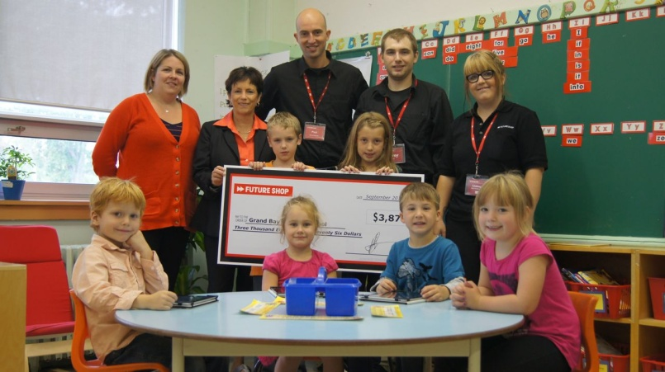

Grand Bay Primary was presented with a cheque for $3826, on Tuesday, September 24, 2013 through the Future Generation Tech Lab Grant Program. Kindergarten teacher, Mrs. Boucher submitted the application and Grand Bay Primary was one of fifteen schools across Canada to receive the grant which will improve classroom technology and elevate student learning.

Seated: Reese Jones, Jacqueline Collins, Jackson Duplessis and Lara Bordage

Cheque holders: Sam Rice and Sofia Oliver

Mrs. Boucher-Kindergarten Teacher, Mrs. Lewis-Principal, Mr. Morrell-Future Shop-General Manager, and employees Corey Dempsey and Lindsay Harris.