GRAND BAY PRIMARY AND INGLEWOOD SCHOOL WILL
JUMP ROPE FOR HEART ON FRIDAY, June 7, 2013
Inglewood School has been Jumping since 1987 and has raised a total of $67,305.38
Grand Bay Primary joined the Jump in 2008 and has raised a total of $14,946.69
I would like to share a special story, about two children who will inspire us as we Jump Rope for Heart.
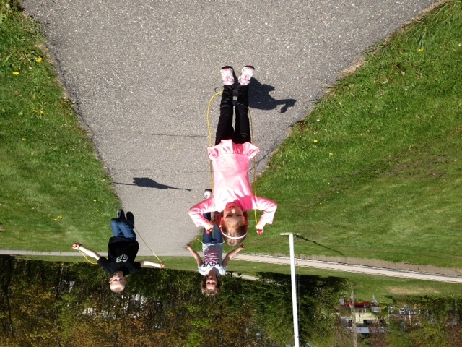
Our very own kindergarten student, Sophia Bossenberry, and students Callie Little and Quinn Richard will be jumping extra hard as they know how important it is to have a healthy heart!! Please take a moment to view this video to hear about Sophia’s story.
http://www.youtube.com/watch?v=HylI6Q3FsE4&feature=youtu.be
To view this video, please right click and select “open hyperlink”.

