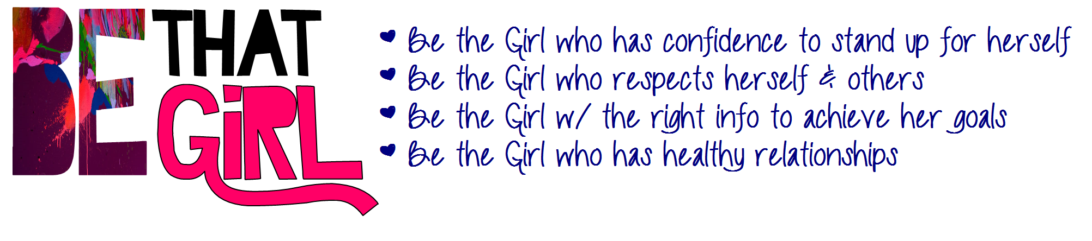

Over 3 days you can learn more about being this type of girl. There will be guest speakers to give information on gaining confidence and achieving success in high school. There will also be opportunities to have fun and gain skills that will help make high school an awesome time.

Call Tanya at 632-5758 to register

for this FREE summer program.