[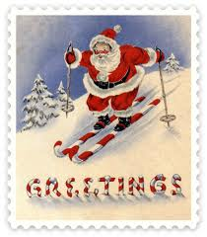](http://www.google.ca/imgres?q=skiing+free+clip+art&um=1&hl=en&safe=active&sa=N&biw=1366&bih=622&tbm=isch&tbnid=UybAdesEutDDhM:&imgrefurl=http://www.epicski.com/t/108229/seasons-greetings-2011&docid=ASHsfHAE7bdx7M&imgurl=http://cdn.epicski.com/6/68/68f58bae_free-vintage-santa-on-skis-clip-art.png&w=420&h=480&ei=CVumUKPcHMuA0AHVkYHIBw&zoom=1&iact=hc&vpx=125&vpy=10&dur=105&hovh=240&hovw=210&tx=134&ty=93&sig=100618882258657796632&page=3&tbnh=138&tbnw=128&start=51&ndsp=30&ved=1t:429,r:51,s:0,i:225) [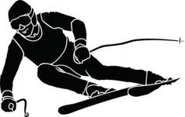](http://www.google.ca/imgres?q=skiing+free+clip+art&start=109&um=1&hl=en&safe=active&sa=N&biw=1366&bih=622&tbm=isch&tbnid=etHwiF0PsOtmvM:&imgrefurl=http://www.clker.com/clipart-140208.html&docid=6n22tH25iF6oLM&imgurl=http://www.clker.com/cliparts/2/b/0/2/1313702860196776750Skier%20Silhouette.svg.med.png&w=298&h=189&ei=dFymUInkCYbh0wHb-ICQDA&zoom=1&iact=hc&vpx=312&vpy=160&dur=528&hovh=151&hovw=238&tx=81&ty=67&sig=100618882258657796632&page=5&tbnh=143&tbnw=225&ndsp=28&ved=1t:429,r:10,s:100,i:34) 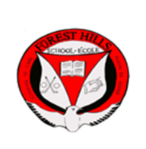

Forest Hills School Ski Team

Once again it’s that time of year, it’s getting colder and we are thinking about winter. We are starting to organize our school ski program which will start in January. We will ski every Thursday night, weather permitting for six weeks. It will cost one hundred and sixty dollars ($160) for the six week program. This will cover the cost of lessons each night, rental of ski or snow board equipment, including a helmet which is mandatory, and the cost of transportation from the school to the mountain and back. We have space for thirty skiers. If you wish your son or daughter to participate please fill out the waiver form and return it to school with money. Receipts for tax purposes will be given. No cheques please.

If you have any questions please contact Mr. Fequet at 658-5338 or e-mail alfred.fequet@nbed.nb.ca

Six week program including transportation

Full package: lift lesson and rental $160

Lesson and lift: has own equipment $120

Lesson and rental: Season pass holder $120

Lesson only: pass holder and own equipment $80