

E X P O

**What is it?**

**An opportunity to experience an educational evening with guest speakers, resources and interactive activities**

**Who is it for?**

**Everyone is welcome!**

**Where will it be held?**

**Kennebecasis Valley High School**

**398 Hampton Road, Quispamsis**

**When will it be held?**

**Thursday, November 6th**

**6:30 ~ Kiosks**

**7:00 – 7:50 ~ Speakers and Presentations**

**7:45 – 8:30 ~ Reception**

**Do I need to register?**

**Absolutely not and Absolutely FREE, we welcome you to join us!**

**[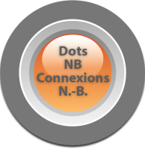](http://www.dotsnb.ca/index.php) [](http://web1.nbed.nb.ca/sites/ASD-S) **