|  |  |  |  |
| --- | --- | --- | --- |
| Hoodie*  $35 | Shorts  $25 | Clinch Bag  $20 | Soft Shell Jacket $50 |

|  |
| --- |
| ***Cash Only*** |

|  |
| --- |
| All items EXCEPT House Colours will have name embroidered. |

|  |
| --- |
| Name for Embroidery |

|  |
| --- |
| House Colours Dri Fit  Green, Purple, Blue , Yellow  $20 |

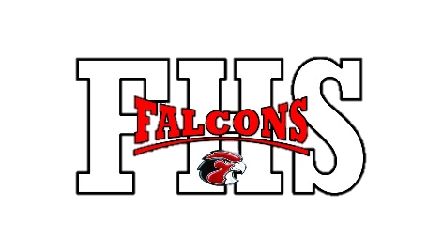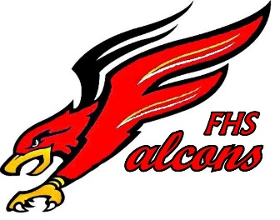[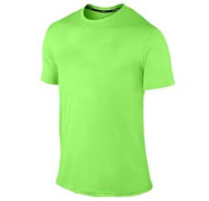](https://www.google.ca/imgres?imgurl=http://www.onlyteez.com/wp-content/uploads/2015/02/piping-green-dri-fit-t-shirt-wholesaler.jpg&imgrefurl=http://www.onlyteez.com/wholesale/dry-fit-t-shirts/&docid=EyOZEKfmchFexM&tbnid=FGWR7tRm-pyqcM:&vet=10ahUKEwjg1NXkt8DWAhUV8WMKHYnXCcgQMwh7KEwwTA..i&w=251&h=242&safe=strict&bih=900&biw=1280&q=green%20dri%20fit%20shirt&ved=0ahUKEwjg1NXkt8DWAhUV8WMKHYnXCcgQMwh7KEwwTA&iact=mrc&uact=8)[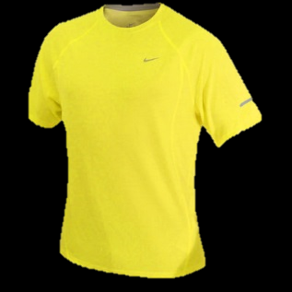](http://www.google.ca/url?sa=i&rct=j&q=&esrc=s&source=images&cd=&cad=rja&uact=8&ved=0ahUKEwiK_OufwsDWAhVOVWMKHWMgB_YQjRwIBw&url=http://www.skidvd.co.uk/27068-s-nike-yellow-dri-fit.php&psig=AFQjCNHlyRITvRGhRvXv2x8zwkr1bJtIjA&ust=1506435092142175)[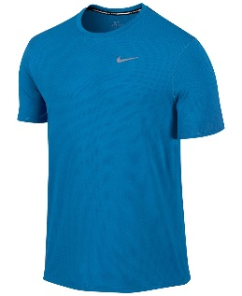](https://www.google.ca/url?sa=i&rct=j&q=&esrc=s&source=images&cd=&cad=rja&uact=8&ved=0ahUKEwjwz4L-wcDWAhVL2WMKHfwbC_EQjRwIBw&url=https://www.lyst.com/clothing/nike-mens-contour-dri-fit-short-sleeve-running-shirt-light-photo-blue/&psig=AFQjCNGNKIp3nBRT10SEL3DBTJjUG3xE7g&ust=1506435035961967)[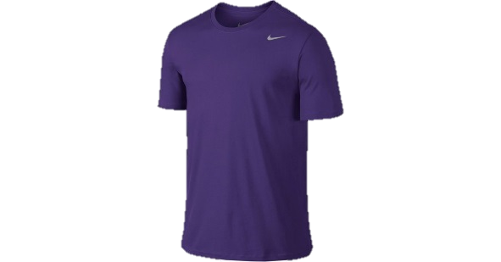](https://www.google.ca/url?sa=i&rct=j&q=&esrc=s&source=images&cd=&cad=rja&uact=8&ved=0ahUKEwiH4IekucDWAhVF12MKHellCjYQjRwIBw&url=https://www.lyst.com/clothing/nike-dri-fit-cotton-short-sleeve-20-t-shirt-court-purple/&psig=AFQjCNGeLKFzw9RM4XfA99NyuWNZdZ3FYw&ust=1506432681477268)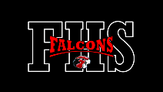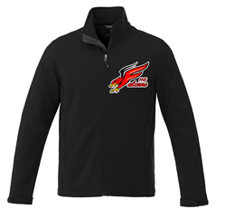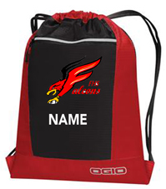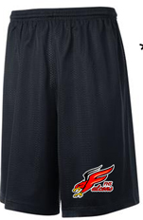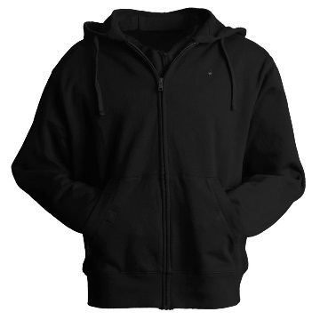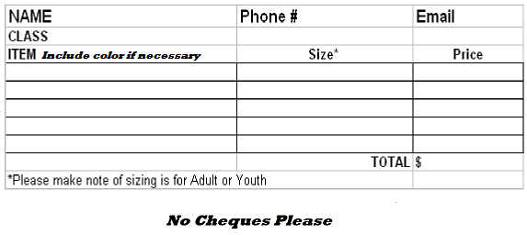

*Orders due Oct. 13*

***Hoodies come in pull over style. Black or Red Please indicate colour on order form below.