**PSSC Letter re: MNS name**

To: Parents of Millidgeville North School

Fr: Parent School Support Committee (PSSC)

As many of you probably know, Millidgeville School began as a high school in 1969 and continued until 1992. At that time it became the main school for Early French Immersion (EFI), and the entire school was dedicated to EFI. In recognition of its place as a bilingual educational institution, the school came to be known as École Millidgeville North School ÉMNS), although an official name change was never processed. Not long after, other schools in the district began to offer EFI. This had an impact on the enrollment at ÉMNS, and the decision was made to offer a split curriculum of EFI and English programs, which we still have today.

Approximately 4 years ago, the PSSC of the day approached the Department of Education to see if the school name could officially be changed to École Millidgeville North School. The Province’s reply was that we are an English School in an English District, no other school offering EFI had a bilingual name and therefore they were not inclined to approve the change. Last year, your PSSC revisited the topic with the District Education Council (DEC) and received the same response.

At the last meeting of PSSC, we discussed this topic again. The committee decided that it was important that the school was consistent in applying the proper school name in all situations. It does not make sense to call ourselves one name when our official name is something else. For this reason, and from here on in, all official references to the school will be with its official name, Millidgeville North School. This, in no way, diminishes the importance of the bilingual aspects of our curriculum. French will still be a very important part of our culture here. Our students and our staff are what make us a community of learners, not the name. Thank you for your understanding.

On behalf of your PSSC,

Bernie Regenbogen, Chair

**Dots NB – Mental Health Awarness**

Friday, December 6 is Dots for Kids/Ring a Bell for Mental Health Awareness. All students are encouraged to bring a bell to ring on Friday at noon to stand united with thousands of students across the province.  For more information about this campaign please visit [www.dotsnb.ca](http://www.dotsnb.ca)

**Holiday Celebrations at MNS**

Our Elementary concert titled "December 'Round the World" will take place Wednesday December 18th at 11am with our annual turkey dinner taking place at 12 for middle school students and 12:30 for our elementary students. Dinner tickets are $6 each and parents are welcome to join us for the meal served by our school’s cafeteria. Order forms have been sent home with students and are due back with payment by December 11th. Late orders will not be accepted.

**Empty Stocking Fund**

Thank you to students for their generous contributions on behalf of those less fortunate in our community. We had a lot of fun playing sabotage and raising the money for the ESF. A cheque was presented by our MNS choir after their performance. Here are the results of our Sabotage game:

Crosby – $38.56

Fillion – $21.24

Ferguson – $58.45

Dempster – $25.85

Vallis – $16.93

Matthews – $109.53

McLaughlin – $17.59

Craig – $26.44

**Cyr – $9.38 – THE WINNER**

Sullivan – $30.59

Kirkpatrick – $41.13

Arsenault – Basque – $43.60

Lamb – $134.39

Watson – $121.99

Nelson – $59.82

Corey – $40.93

Fox – $78.56

Gignac – $33.02

The total amount raised was $ 913.04!!

**Cheer Team Fundraiser**

Our MNS Cheer Team is collecting donations of clothing as a joint fundraiser for the team as well as the Canadian Diabetes Foundation. Donation items can be dropped off to the office until December 13th.

**Food Bank Donations**

We are still collecting donations for the North End Food bank. If you would like to make a contribution please send in items with your child or drop them off to our office.

**Celebrations**

*Mme Dempster would like to celebrate her class for raising $60, that we donated to the Empty Stocking Fund.

*Mme Dempster would also like to celebrate Nick Bates for helping another student out when they did not have enough money to purchase their drink in the cafeteria!

*Mme. Price would like to celebrate all of the staff who have been working very hard to be ready for our school review next week.

*Mme. Price would like to celebrate the parents who help with the many activities and events at MNS. Our wonderful parent volunteers have helped us with such things as our parade float, the Scholastic book fair, Food bank donations, Cheerleading and Hockey team fundraising, accompanying school choirs and assisting sports teams. THANK YOU!

*Mme. Price would like to celebrate Mr. Corey, Ms. Lamb and Ms. Price for all of their work in fundraising and performing for the Empty Stocking Fund.

*Mme. Price would like to celebrate Mrs. Kirkpatrick and Mrs. Fox for coaching the middle school badminton teams.

*Mme. Price would like to celebrate MNS librarian Ms. McCaughn for re-organizing the library and ensuring that all of the books are put on the shelves for our students to enjoy.

*Mrs. Kinney would like to celebrate the parents who helped with the scholastic Book Fair that was held last week. A special thanks to Debbie Higgins, Christie Georgoudis, Andrea Titus, Wendy Field, Cathy Connolly-White, Nancy Fisher and Brian Li.

**Scholastic Book Fair**

Last week our book fair raised a total of $2975.45 in sales which translates into a Scholastic credit of $1383.58. This credit is used to purchase books and resources for our school and students.

**School Library**

We would ask that all MNS library books be returned before December 20th. This helps to ensure that books do not get misplaced over the holidays. Thank You.

**Character Education Themes**

Every month we celebrate a different character education theme. During the month of November we focused on Empathy. The following students were recognized by their homeroom teacher as a student who shows this quality:

*Shaylee Owens-McKillop*

*Laura Morrow*

*Ben Coates*

*Xavier Hovey*

*Ejub Balihodzic*

*Jordan Knudson*

*Jacob Hughes*

*Angelina Tiffin*

*Regan LeBlanc*

*Robyn Moore*

*Mitchell Ross*

*Ethan Devereaux*

*Caleb Higgins*

*Nick Moore*

*Brooklyn Clarke*

*Austin Lemieux*

*Sarah Simon*

*Hooriya Sher*

This month we celebrate the theme of kindness. Kindness is the quality of being warm-hearted, considerate and sympathetic towards others.

**Last & First days of school**

The last day of school before the break is Friday December 20th and that will be a full day of school. In the New Year, teachers will return on January 6th for professional learning sessions while students return on Tuesday January 7th.

**School Review**

Each year there are several schools within the province which participate in a school review process. This year Millidgeville North School is one of these schools. On December 10th, 11th, and 12th, personnel from; district office, the department of education, as well as a local administrator, will be in our school to observe the daily operations of Millidgeville North School. The school review is an opportunity for MNS to determine areas of strengths as well as areas for growth. We look forward to taking part in this positive learning experience.

**School Mission Statement**

The mission of MNS, a diverse family of learners, is to develop independent and confident community members. By promoting kindness and responsibility within our school, we create a nurturing and positive learning environment.

**School Vision Statement**

MNS’s vision is to:

STRIVE for high expectations & academic excellence

TEACH the whole child

APPRECIATE and celebrate diversity

RESPECT needs, interests and abilities

SHARE within our community

**Polar Bear Symbolic Adoption**



In honour of our school mascot, MNS has adopted a polar bear family! This Symbolic Wildlife Adoption is a meaningful way to inspire school spirit and encourage kindness (this month’s character theme focus). The adoption helps support the conservation efforts of WWF and helps to protect wildlife and their habitats. Adoptions are symbolic, which means that we are helping to save all animals at risk, not just one. WWF works around the world to help protect species at risk and the habitats they call home. Our support goes a long way in helping make these efforts possible.

**Hockey Fundraiser**

**Bake/Yard/Book Sale**

**Saturday, December 7, 2013**

**Millidgeville North School Cafeteria**

**9am – 1pm**

Fundraising for Millidgeville

North Stars Hockey Teams

C:\Users\mcgloat\AppData\Local\Microsoft\Windows\Temporary Internet Files\Content.IE5\5GTX5RD6\MC900434583[1].wmfBOOKS FOR ALL AGESC:\Users\mcgloat\AppData\Local\Microsoft\Windows\Temporary Internet Files\Content.IE5\SDL5C8BG\MC900391506[1].wmf

50/50 DRAW

LOTTERY/GIFT BASKET DRAW CHRISTMAS GIFTS

CHRISTMAS BAKED GOODS

USED ITEMS AT GREAT PRICES

SCENTSY BASKET DRAW

Come out and support your

community hockey!

Donations at the door for the

North End Food Bank

C:\Users\mcgloat\AppData\Local\Microsoft\Windows\Temporary Internet Files\Content.IE5\5GTX5RD6\MC900239505[1].wmf

**School Closures & Delays**

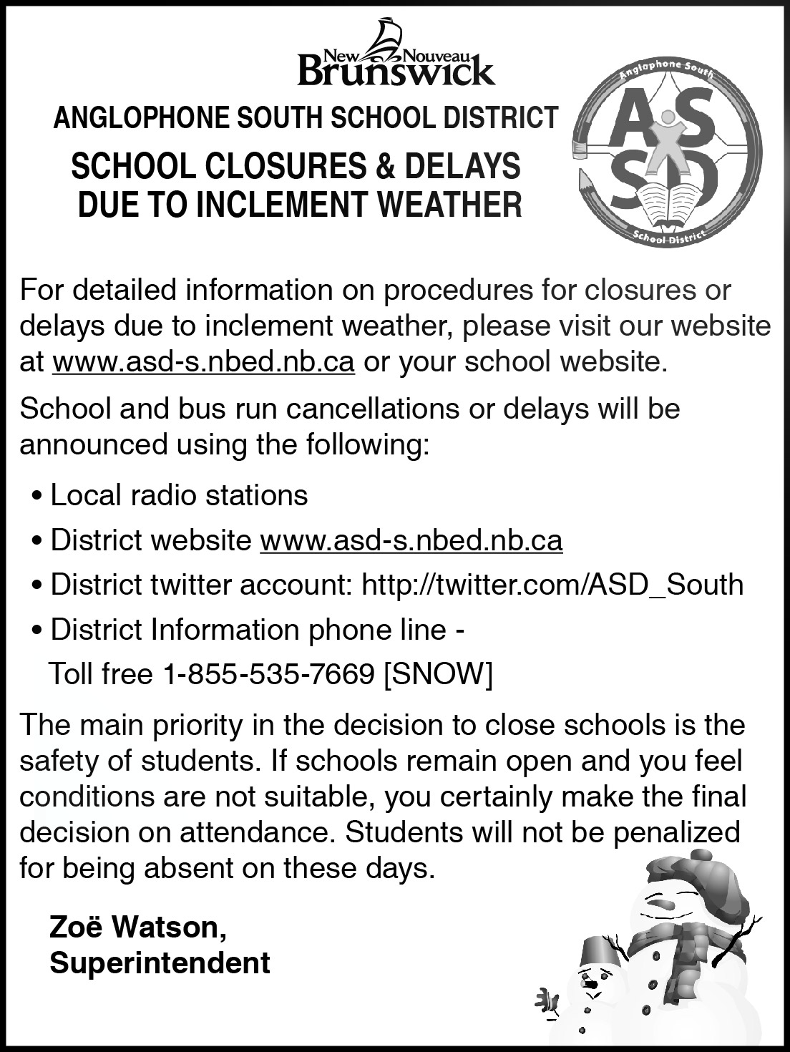

**Important Dates**

Dots NB ring a bell campaign: December 6th

SJ String Quartet performance: December 9th

PSSC Meeting: December 9th 7-8pm

School Review: December 10-12th

Choir sings at Kennebec Manor: December 17th

Christmas Concert & Dinner: December 18th

Last Day of School for 2013: December 20th

First day for students in 2014: January 7th