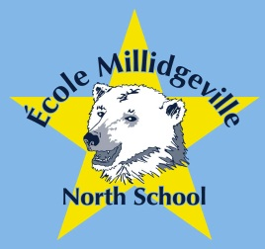École Millidgeville North School

Grades 3 to 8 French Immersion and English Programs

500 Woodward Avenue, Saint John, NB, E2K 4G7

Phone: 658-5353   Fax: 658-2739

Michael Whelton, Principal Michelle Price, Vice-Principal

September 17, 2013

Open House PSSC- Election École Milldgeville North

Welcome parents and guardians to École MillidgeVille North’s 2013 Open house- PSSC Election.

5:30 pm BBQ in Cafeteria sponsored by Sobeys Lansdowne Place

6:00 pm Principal Welcome and Introductions of Teachers, PSSC and Home & School

6:30-7:00pm Meet your child’s teacher (s) during classroom visits.