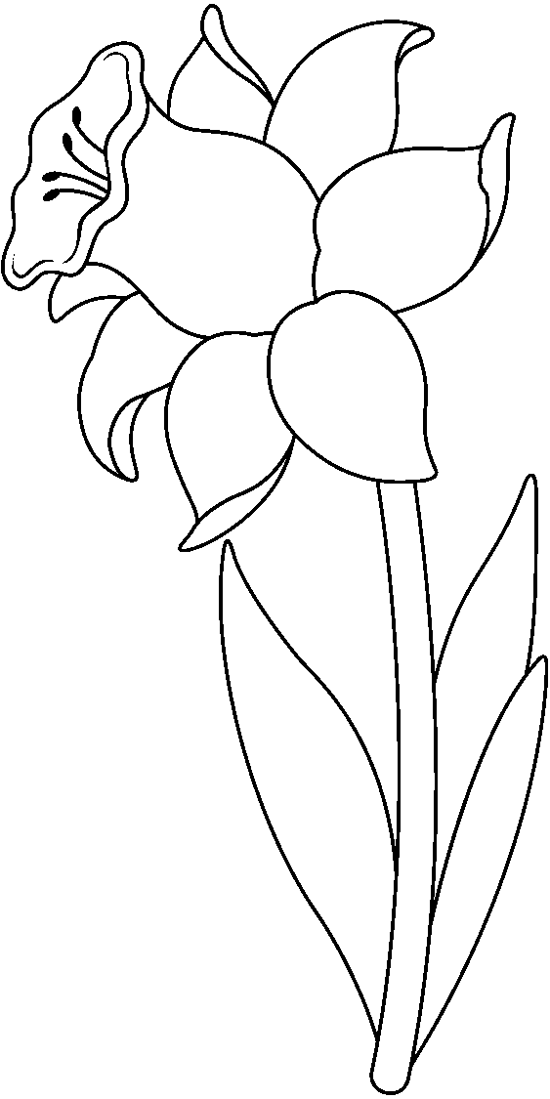

Follow your favourite Winter Market Vendors…

Scentsy, Stella and dot,

Shelly's sea glass, Loops Designs

Mary's sewn creations, Suzanne's Jamberry Nails

Sunset Gourmet, Darla's Creations

L2 Creations, Together Jewellery and scarves

Oh!Wow Crochet, Tartanish

Mary Kay Skincare, Seacret Skin Care

Avon, Silpada/Dione makeup

J.R. Watkins, It Works Products

Jazz It Up/Fabulous Finds

Tupperware, Pampered Chef,

Sweet Legs Leggings, The Fudge Lady

Epicure, Barefoot Books

Crafty Creations for kids, Your Inspiration at Home

Drops of Mercy, Younique & Shaklee

And more, come out and support local

Millidgeville North Spring Market

Fundraising effort by the Millidgeville North Home and School Association

### Multiple Food Vendors

# Locally made products

## Saturday, March 14th 9am-2pm

Millidgeville North School, 500 Woodward Avenue,

Anglophone South School District Entrance