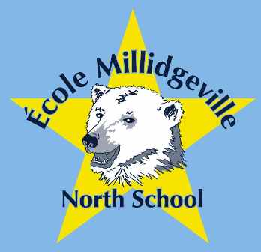 Ecole Millidgeville North School

500 Woodward Ave Chair: Louise Kinney
Saint John, N.B. Treasurer: Tina McGloan
E2K 4G7 Secretary: Debbie Higgins

658-5352 Web site: under construction

emns.nbed.nb.ca
Dear Parents/Guardians,

We would like to invite you to join the Ecole Millidgeville North School (EMNS) Home and School Association. This is our fifth year re-establishing our Home and School association and we are pleased with our accomplishments. We are always looking for volunteers to help with the many activities we would like to put together for our children at EMNS and what a better way for parents to feel connected to EMNS.

The Home and School Association is a group of parent volunteers that are interested in enhancing their child’s educational experience. It provides a vital link between the home and the school. We promote quality education for all children. Home and School Associations provide an independent voice for parents to government and represents you on such Provincial government committees as: Testing & Evaluation and The Provincial Curriculum Advisory Committee.

Our EMNS Home and School Association would like to focus our efforts with the following:
- Develop a home and school distribution list whereby parents can receive monthly communications on what activities the Home and school is supporting and going on throughout the school.
- The Home and School would work as volunteer coordinators such that if teachers or the administration needed support for activities throughout the year; the Home and School would help them fulfill that need.
- Extracurricular activities: Hold several fun events over the school year that would be for elementary and middle school students
- Initiatives directed from the School Administration within the School Improvement Plan.

Our Home and School will have monthly meetings this year which will start on September 26th and the rest of the years information will be sent out via email. You can be a part of our email distribution list to receive copies of the Home & School information, so you can stay in touch with what is happening at the school.

Please return the bottom portion of this form to your child’s teacher if you would like to be part of the Home & School Association or email Tina McGloan at mcgloan.cb@gmail.com.

NAME(S):___________________________________ CHILD’S NAME:__________________________

CHILD’S TEACHER:___________________________ EMAIL

