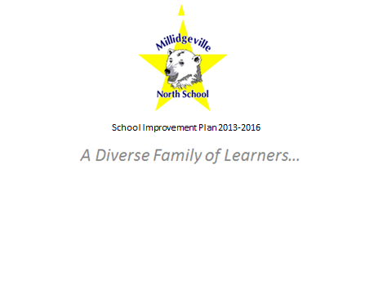

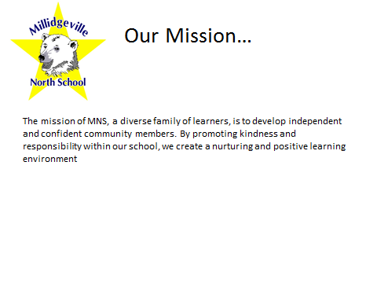

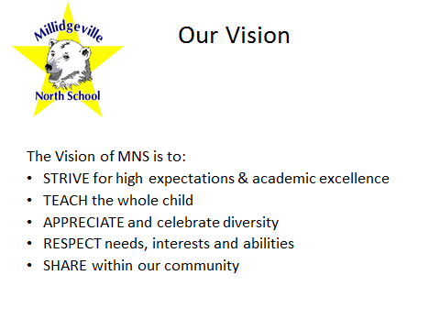

1 To demonstrate continuous progress toward curriculum outcomes in literacy, numeracy, science and technology (English and French Immersion).

Goals | Strategies | Indicators of Success | Timeline | Responsibility
1.1 Support classroom teachers in the planning and implementing of effective instructional practices to meet the diverse needs of students. | - Exploration of Universal Design for Learning principals for school wide implementation. | - School wide participation in Provincial and District supported Professional Development  - Book Study/professional  - Teacher Professional Growth Plans will be aligned to the SIP goal 1.1  - Creation of UDL team to enhance knowledge and practice and serve as leads within the school.  - UDL team to attend a CAST Professional Learning Conference  - Survey teachers to measure teacher readiness of UDL and planning of next steps  - Classroom observation/feedback, both peer and administration  - Sharing of UDL practices at staff meetings | - UDL PD October 10th , 2013  - Book study 2013, readings ongoing  - Ongoing  - UDL team – October 2013-16  - Conference 2013-14  - Spring 2014  - Ongoing  - Ongoing | Administration/school wide  Michelle Price, Administration, Core Leadership, UDL Team  Administration  UDL team  UDL team  Core Leadership Team  Administration  teachers
 | - Develop class/school profile to be used school wide; based on academic, social, Multiple Intelligences, Interest Inventory, SEP, EAL, strengths and needs. | - Creation of an effective student profile, which will follow the student through their school career, to aid in planning and preparation for student learning (UDL)  - Use profiles to improve Response to Intervention  - Use profiles to provide more enrichment opportunities to enhance student learning  - Create a protocol for incoming students (orientation, assessment, resources, buddy system) | - Developed by June 2014, implemented September 2014  - 2014-15  - 2014-16  - 2014-16 | Staff  Teachers  Teacher  ESST
 | - Participate in the Provincial School Educational Review and implement recommendations for school wide growth. | - Creation of Internal School Review Team  - Exploring indicators to establish priorities within our school  - Participating in school review  - Using feedback to revisit SIP to ensure school wide growth | - September 2013  - September-December 2013  - December 2013  - January 2014-16 | Administration  Internal Review Team/Whole staff/parents  Staff/parents/students  Staff
 | - Implement new Provincial Instructional Time Guidelines. | - Plan and implementation | - May 2014 - 2016 | Administration/Core Leadership Team
Goals | Strategies | Indicators of Success | Timeline | Responsibility
1.2 Implement effective school wide common assessment practices. | a. PD on best assessment practices. | - Mentors and lead teachers to aid in facilitating, co-teaching, coaching, on assessment practices.  - Peer observations, collaboration and sharing  - PLC time for moderated marking  - Teacher online responses to monthly professional readings | 2013-2016  2014-2016  2014-2016  2013-2016 | Administration and Lead teachers  Teachers  Administration, teachers and Leads  Administration and teachers
 | - Collection of data. | - Utilizing data (formative and summative) to inform instruction and future assessment  - Collection of data from benchmarks and posting to E-Binder/dashboard  - Year-end data based on common assessments for Math & Literacy will be included in Student Profile and shared with and used by teachers | Ongoing  2014-2016  2014-2016 | Administration and teachers  Administration, teachers, Mentors, and Marc Godin  Administration, teachers, Mentors
 | - Develop school wide assessment plan which correlates with reporting times and District Assessment Plan. | - creation of team to develop Literacy Plan  - creation of team to develop Numeracy Plan  - Walk through data | May 2014  May 2014  Ongoing | Administration, teachers, Mentors  Administration, teachers, Mentors  Administration, teachers
1 To demonstrate continuous progress toward curriculum outcomes in literacy, numeracy, science and technology (English and French Immersion). Cont’d

2. To provide positive and safe learning Environments for children, teachers, and staff.

2.1 provide positive and safe environment | a. review and update the school PLEP (Positive Learning Environment Plan) to promote, create and maintain a positive, safe and inclusive environment. | - Teacher Handbook creation to include (Merging of Resource Binder, PLEP and Student Profiles)  - An updated and revised school plan will be completed | Spring 2014  Nov. 2013 | Administration, teachers  Administration, teachers
 | b. review & update school pyramid of intervention in order to implement interventions to reflect school need. | - Will be added to Teacher Handbook  - Norms for use of behavior tracking  - data will reflect positive changes in the Learning Environment as indicated in the Tell Them From Me (TTFM) and Winschool | Spring 2014  Sept. & Feb. 2013-2016  Nov. 2014 | ESST  Administration, teachers  Administration, Staff
 | c. EMO/Crisis Protocol developed. | - EMO team to update and review roles and responsibilities  - EMO Plan will be practiced twice a year  - Fire Drill Monthly  - A crisis plan and phone tree will be developed  - Health and Safety Committee minutes will be placed on the portal to be shared with staff | Ongoing  Ongoing  Ongoing  Spring 2014  Monthly | Michael Whelton, EMO team  EMO team, Administration  Administration, Plant Supervisor (Wally Cruickshank)  Administration, Core Leadership Team  Michael Whelton, Health and Safety Committee

.

Goals | Strategies | Indicators of Success | Timeline | Responsibility
3.1 Provide a variety of ways to strengthen communications with family and community. | a. seek information on how parents want to receive information (paper, voicemail, email, twitter). | - Completed survey and make necessary changes to reflect the needs of the parents/guardians | Spring 2014 | Michael Whelton
 | b. revisit and update school website. | - Completed website | Ongoing | Michael Whelton
 | c. Promote consistency and frequency of communication with parents. | - Creation of classroom websites and/or news letters, and use of Weekly School Star newsletter  - greeting phone calls | Ongoing  Sept. 2013-16 | Administration, teachers  Teachers
 | d. Community Involvement. | - Open House/Meet the Teacher BBQ  - Family Fun Night  - Movie Nights  - Christmas Parade Float  - Business Partnership  - Home and School /PSSC  - Parental Forum for School Review | Sept. 2013-16  June 2013-14  Ongoing  Nov. 2013-16  Ongoing  Ongoing  Oct.-Dec. 2013 | Staff  Staff, Student  Administration, teachers  Teachers, Home & School parents, students  Administration  Administration, teacher rep and parents  Administration, parents
3. To strengthen engagement of families and foster community partnership

