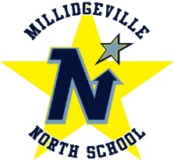
MNS
Millidgeville North School
500 Woodward Ave
Saint John, NB E2K 4G7
Tel: (506) 658-5353

Principal: Matthew Bedard Vice-Principal: Michelle Price

On behalf of the staff we would like to thank all the families who visited MNS this past week to gather student belongings. Your involvement with the plan was exceptional and allowed for a very smooth and well-coordinated activity. It was nice to see faces again and the brief check ins brightened the days for all of us here.

MNS is now in the position to be able to offer access to MNS for essential workers and other families who could not make one of the three past days to gather student personal belongings.

Tuesday, May 12th from 5:00 to 7:00pm families who did not have an opportunity to enter MNS will be able to gain access to students’ personal items. This will be the last opportunity to do so.

Keeping in mind social distancing guidelines.
- Entry to school is only allowed through main front doors (It will be identified by pylons)
- Once in the school lobby there will be a check and gloves will be available.
- After check in parent/student can proceed to lockers to get items.
- You must provide bags to carry items.
- Once items are gathered you will be directed to an exit close to your locker/classroom
- Washrooms and fountains cannot be accessed, and we ask that this is done as quickly as possible.

Thank you

