PROGRAMS FOR THE WINTER (JANUARY— MARCH) 2016
Dates & times may change. For more information or to register, phone (506) 633-2182

****** FOR ADDITIONAL PROGRAMMING, PLEASE SEE THE OTHER SIDE ******

FOR CHILDREN:
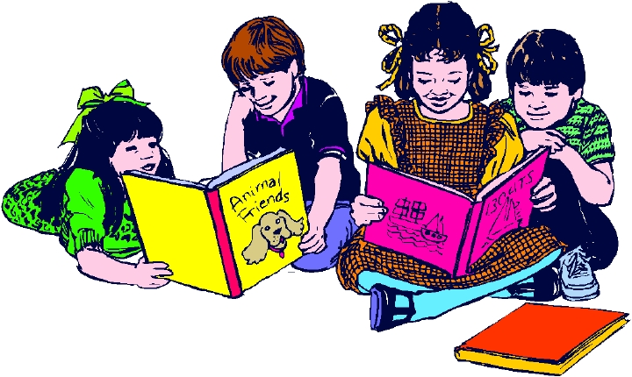

Children's Library

Offers a selection of English & French children’s books.

Read with your child today!

Parent - Child Playgroups

Parents/caregivers increase your parenting skills while your children

increase their social and emotional skills. Crafts, songs and stories.


Main Centre  211 Wentworth Street  Tuesdays 10am-12pm  Wednesdays 10am-12pm  Thursdays 10am-12pm  More information call  Karen at 633-2182 | Urban Outreach  Tuesdays 10am-12pm:  Westside Carleton Community Centre  Wednesdays 10am-12pm:  Glen Falls School  Thursdays 10am-12pm:  Crescent Valley Resource Centre  More information call  Miranda at 633-2182 | Rural Outreach  Mondays 10am-12pm: Fundy Shores School  Tuesday 10am – 12pm: Garnett Settlement Church  Wednesdays 10am - 12pm  Nerepis Baptist Church (Starting Feb. 10th)  Thursdays 10am-12pm: Barnesville Presbyterian Church  More information call  Pattie at 633-2182

FOR FAMILIES:
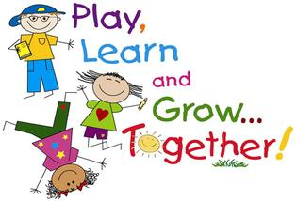

“A place where children are learning to play and playing to learn”

Matinée Portes Ouvertes

Parents/Guardiens francophones et enfants de 0 à 5 ansil, au Centre de ressources de famille. Le lundi, 8 févier 2016 - 10h00 à 11h30. Renseignements & Inscription: Patricia - 633-2182.

PROGRAMS FOR THE WINTER (JANUARY— MARCH) 2016
Dates & times may change. For more information or to register, phone (506) 633-2182

****** FOR ADDITIONAL PROGRAMMING, PLEASE SEE THE OTHER SIDE ******

PARENT/CHILD
PROGRAM:

"The FUN FRIENDS program is designed to teach young children practical, useful strategies for coping with stress, worry, fear and sadness (i.e. how to be brave, solve problems, think positively, relax and face challenges)." "FUN FRIENDS will help parents/children learn valuable coping life skills together as a family, in a FUN way!!" Building Resilience Program (8-week program), for Parents / Caregivers 4-5 year olds, Friday mornings, 10am - 11:30am, Mar. 18th - May 13th (no session Mar. 25th, Good Friday). Registration required. Childcare and transportation support may be available. For more information call Karen at 633-2182.

FOR PARENTS:
Community Kitchen

Join us for creative planning and meal cooking on a budget and our "Food Facts" information sessions!!! Planning menus and Food Facts Feb. 15th, Mar. 14th, Apr. 11th, & May 16th. Cooking takes place Feb. 22nd, Mar. 21st, Apr. 18th & May 30th. Monday mornings, 9:30am - 12:30pm. You are required to attend both the planning & cooking sessions. Registration and childcare are limited. Please call the centre at 633-2182 for more information.



Adult Library

A variety of books on parenting, personal development, health and more.




"Frères et Soeurs sans Jalousie Ni Rivalité"

Un programme de six sessions hebomadaires offerons aux parents d'enfants. Le mercredi, 23, 30 mars, 6, 13, 20, et 27 avril. 18h30 - 20h30. Aide disponible pour le transport et le garderie. Rensignements & inscription: Linda 648-8022

COMING SOON
Prenatal and Parenting Programs for moms 15 -24 years. old.

