PROGRAMS FOR THE SPRING (APRIL — JUNE) 2016
Dates & times may change. For more information or to register, phone (506) 633-2182
FOR FAMILIES:

FOR CHILDREN:
****** FOR ADDITIONAL PROGRAMMING, PLEASE SEE THE OTHER SIDE ******

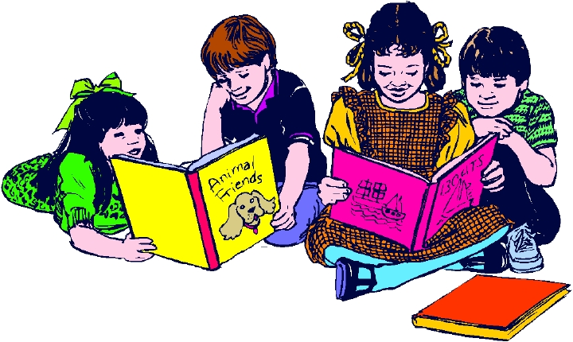

Children's Library

Offers a selection of English & French children’s books.

Read with your child today!

Parent - Child Playgroups

Parents/caregivers increase your parenting skills while your children

increase their social and emotional skills. Crafts, songs and stories.


Main Centre  211 Wentworth Street  Tuesdays 10am-12pm  Wednesdays 10am-12pm  Thursdays 10am-12pm  More information call  Karen at 633-2182 | Urban Outreach  Tuesdays 10am-12pm:  Westside Carleton Community Centre  Wednesdays 10am-12pm:  Glen Falls School  Thursdays 10am-12pm:  Crescent Valley Resource Centre  More information call  Miranda at 633-2182 | Rural Outreach  Mondays 10am-12pm: Fundy Shores School  Tuesday 10am – 12pm: Garnett Settlement Church  Wednesdays 10am - 12pm  Nerepis Baptist Church  Thursdays 10am-12pm: Barnesville Presbyterian Church  More information call  Pattie at 633-2182

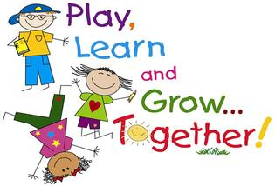

“A place where children are learning to play and playing to learn”

FOR MOMS TO BE:
Family Resource Centre Prnatal Program

Our prnatal classes are especially designed for moms to be age 24 years and under and their support people. Beginning April 14th - May 12th, (Thursdays) from 6pm - 8pm. Please call Joy at 633-2182 for more information.

PROGRAMS FOR THE SPRING (APRIL — JUNE) 2016
Dates & times may change. For more information or to register, phone (506) 633-2182

****** FOR ADDITIONAL PROGRAMMING, PLEASE SEE THE OTHER SIDE ******
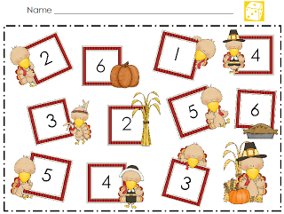

PARENT/CHILD
PROGRAM:
A Recipe For Literacy

For parents/caregivers and their 4-5 yr olds, a 1 ½ hr. weekly session using an interactive, hands-on approach to
literacy where visual aids are used to compliment simple math skills such as sequencing, steps, numbers, etc.,
through a fun cooking program. Fri. 10am – 11:30am, May 20th, 27th, June 3rd & 10th. Registration required.
Limited childcare and transportation support available. For more information call Karen at 633 - 2182.

FOR PARENTS:

Community Kitchen

Join us for creative planning and meal cooking on a budget and our "Food Facts" information sessions!!! Planning menus and Food Facts Feb. 15th, Mar. 14th, Apr. 11th, & May 16th. Cooking takes place Feb. 22nd, Mar. 21st, Apr. 18th & May 30th. Monday mornings,
9:30am - 12:30pm. You are required to attend both the planning & cooking sessions. Registration and childcare are limited. Please call the Centre at 633-2182 for more information.



Conversations With Parents
For parents/caregivers, a 1 hr. weekly information session. Tuesdays, 12:30pm – 1:30pm, Apr.12th: Transition To School, Apr.19th: Road To Reading, Apr. 26th: Nutrition, Eating To Be Healthy, May 3rd: 360 STAND, May 10th: Boundaries, & May 17th: Mental Health.
Transportation & on-site childcare available. Registration required. To register call the Family Resource Centre 633-2182.



Adult Library

A variety of books on parenting, personal development, health and more.

