There is a free playgroup in your neighbourhood!! We look forward to meeting you!!   
 Come meet other Parents and Children

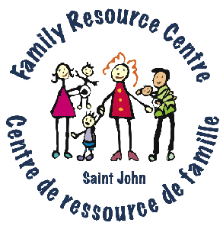

Play – Crafts – Snacks – Stories – Songs

Register when you come for your first visit

For more information call the number for the playgroup closest to you!!

|  |  |  |  |  |  |  |
| --- | --- | --- | --- | --- | --- | --- |
|  | Monday | Tuesday | Wednesday | Thursday | Friday | Saturday |
| South End | 10 am – 12 pm  Infants 0-18 months  Y Early Learning Centre  Saint John the Baptist/ King  Edward School  Wentworth St. & St. James St.  693-9057 | 10 am - 12 pm  0-5 yrs.  Family Resource Centre  211 Wentworth St.  2nd  Floor  633-2182 | 10 am - noon  0-5 yrs.  Family Resource Centre  2 211 Wentworth St. -  2nd Floor.  633-2182 | 10 am - 12 pm  0-5 yrs.  Family Resource Centre  211 Wentworth St.  – 2nd Floor  633-2182 | 10 am - 12 pm  0-5 years    Y Early Learning Centre  Saint John the Baptist  /King Edward School  Wentworth St. &  St. James St.  693-9057 | 10am - 2 pm  Infants 0-18 months  Y Early Learning Centre  Saint John the Baptist/  King Edward School  Wentworth St. &  St. James St.  693-9057 |
| Waterloo  Village |  | 9:30 am -11:30 am  0-5 years  Prince Charles School  317-319 Union St.  693-9057 |  | 9:30 am - 11:30 am  0-5 years  Prince Charles School  317-319 Union St.  693-9057 |  |  |
| Crescent Valley |  |  |  | 10 am - 12 pm  0-5 yrs.  Crescent Valley Resource Centre  130 McLaren Blvd.  633-2182 |  | **C:\Documents and Settings\Owner\Local Settings\Temporary Internet Files\Content.IE5\0LI9I7U7\MM900283629[1].gif** |
| Old North End | 9 am - 11am  0-5 years  Centennial School  10 Constance St.  693-9057 |  | 9 am - 11 am  0-5 years  Centennial School  10 Constance St.  693-9057 |  |  |  |
| Lower West Side |  | 10 am - 12 pm  0-5 years  Carleton Community  Centre  82 Market Place  633-2182 |  |  | clip_art_for_website[1] |  |
| East Side | C:\Documents and Settings\Owner\Local Settings\Temporary Internet Files\Content.IE5\0LI9I7U7\MC900232107[1].wmf |  | 10 am - 12 pm  0-5 years  Glen Falls School  10 Princess Court  633-2182 |  |  |  |